February 26, 2018

Dear CEDA Guests,

It is with great pleasure that the University of Puget Sound welcomes the Cross Examination Debate Association to our campus in Tacoma, WA.

Tacoma, known locally as the “City of Destiny,” is home to the Museum of Glass, America’s Car Museum, Tacoma Art Museum, Washington State History Museum in a robust downtown. In Tacoma, visitors will find easy access to hiking trails, ferryboat rides, commencement bay and the waterfront, as well as Point Defiance, the nation’s second largest urban park. On days when it chooses to show itself, our guardian volcano Mount Rainier dominates the Puget Sound horizon. Our campus is just up the road from Tacoma’s popular 6th Ave, home to many restaurants, local shops and bars. Tacoma is just 25 miles south of Seattle, where competitors will find the famous Pike Place Market, Space Needle, Gas Works Park, Capital Hill Gayborhood, and more. Portland, OR and Vancouver, B.C. are also both within a few hours drive. We are happy to provide this tournament packet listing the numerous amenities available to our guests.

We believe the last time CEDA came to the Northwest was for the 1991 tournament hosted by Western Washington University. We are honored to host the tournament’s return to the Pacific Northwest.

Derek Buescher Austin Brittenham Brittany Williams

Professor Debate Coach Debate Coach

Director of Forensics

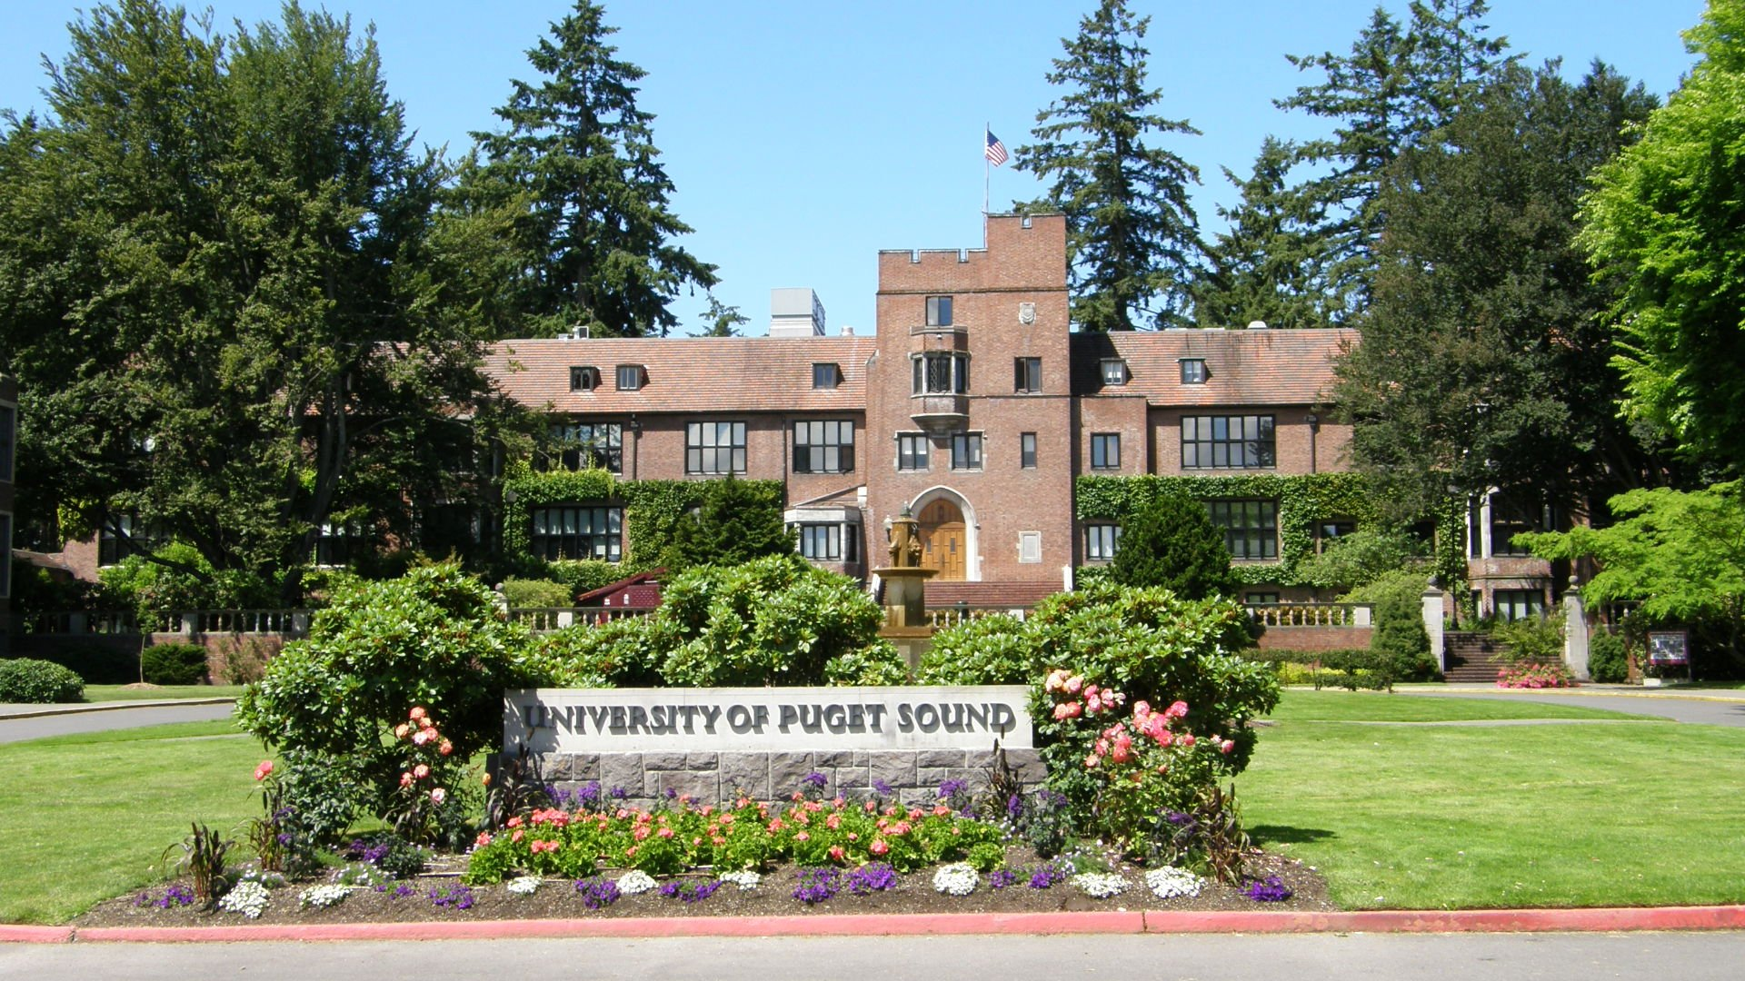

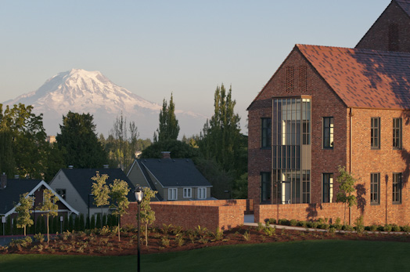

**Tournament Dates**

Wednesday, March 14, 2018 – Arrival/Opening Award Ceremony

Thursday, March 15, 2018 – First Day of Preliminary Debates

Friday, March 16, 2018 – Second Day of Preliminary Debates

Saturday, March 17, 2018 – First Day of Elimination Rounds & Awards Ceremony

Sunday, March 18, 2018 – Second Day of Elimination Rounds & Final Round

Monday, March 19, 2018 – Remaining Teams Depart

We believe this packet will contain the information you need for the tournament. If you need any additional information, please don’t hesitate to call, text or email.

Derek Buescher

Cell - 253-988-0900

Office – 253-879-3272  
Email – [derekbuescher@gmail.com](mailto:derekbuescher@gmail.com)

**Weather –** Weather for the period of the tournament looks like mid-winter in the Pacific Northwest, but our forecasts around here change quickly. Forecast is for rain most every day with highs in the low 50s and lows in the high 30s/low 40s. In other words, expect it to be damp and chilly.

**Directions to Campus –** The campus address is 1500 N. Warner St., Tacoma, WA 98416   
From the hotel you have two primary options:

Option 1: via I-705 and Schuster Parkway. Exit the hotel onto **East 26th** Street and then turn right onto **Portland Ave**. Merge onto **I-5 South** and take **Exit 133 onto I-705**. Keep right to **stay on I-705** and then the left lane to exit onto **Schuster Parkway**. Stay in the right lane and follow **Schuster Parkway** along the bay to **N. 30th Street**. Take a left onto **Alder Street**. Turn right off of Alder at **N. 14th** into parking lot of Wheelock Student Center.

Option 2: via 509. From the hotel turn left onto **Portland Ave.** At the overpass turn left onto **Highway 509** traveling East. Exit onto **I-705** and then the left lane to exit onto **Schuster Parkway**. Stay in the right lane and follow **Schuster Parkway** along the bay to **N. 30th Street**. Take a left onto **Alder Street**. Turn right off of Alder at **N. 14th** into parking lot of Wheelock Student Center.

If you are traveling from another hotel not in Tacoma, take I-5 to exit 133 and follow signs for 1-705, Schuster Parkway, N. 30th. From N. 30th, take a left onto Alder Street and turn right off of Alder at N. 14th into the parking lot of Wheelock Student Center.

**Campus Maps and Building Locations** – You can locate campus maps at: <http://www.pugetsound.edu/about/campus--the-northwest/campus-map/>. This page will provide both an interactive campus map and a printable campus map. Although we are not located in one building, campus is small and easy to navigate. Here are some highlights:

Homesteading – We will headquarter in Wheelock Student Center (WSC) and have use of Lower and Upper Marshall Halls. WSC contains the diner, diversions café (coffee!). bookstore, and Cellar (snacks and other items). Tab will also be located in WSC in the Murray Boardroom. On the printable map, WSC is building 54.

Competition Rooms – We will use the following buildings for debates with building numbers in parentheses: WSC, Trimble (48), Howarth (17), Jones (20), McIntyre (27), Thompson (45), Wyatt (55), Weyerhauser (53) and, maybe, Thomas (44). Please note that Thomas and Thompson are two separate building and it wasn’t my idea to have two buildings with virtually the same name.

Hospitality Room – McIntyre 103 will serve as our hospitality room. We will have some snacks and supplies available in the room. Please stop by if you need something or help finding items.

Parking – Parking on campus is free and over spring break we do not anticipate you needing passes. Should you receive a ticket, please find Derek and we will take care of it. Obviously, do not park in any “special” spots such as accessible spots without proper displays. We can’t help you if you do that. The easiest location to park in lot P1 on the printable map. If that lot is full, then lot P6, just north of WSC always has spaces available.

**Meals-**  The tournament is providing breakfast and lunch the first two days of competition through a voucher system with the diner. The food options in the diner are plentiful and include vegan, vegetarian, and allergen free stations. Dinners as well as breakfast and lunch on day three will be on your own. Please note that the voucher does not cover prepackaged items such as bottled drinks or prepackaged foods. If you would like a bottled drink or a packaged item those will be on your own. The diner will be open from 7:00 am to 8:00 pm each day. In addition, I am also attaching a restaurant list that includes places near campus.

**Internet –** The University of Puget Sound has campus wide wireless coverage via a guest login. Connect to ‘PS- Guest Access” with your computers wireless. However, please note that this network can slow when many people join, especially with multiple devices. The University IT is working now on upgrading the network, but I encourage people to 1) log in with only one device and 2) consider using data or hotspots when needed. If you have difficulty with access please call Information/Media Services at 253-879-8585.

**Quiet Room –**We will have a quiet room in the McIntyre 003. This room will be open throughout the tournament.

**Gender Inclusive Restrooms** – Gender inclusive restrooms are located in most campus buildings in use. The following rooms are Gender Inclusive Restrooms: WSC 112B (near the tabroom), Howarth 108, Jones 015, Thompson 192, 294, 396, 406, Thomas 274, 276, and Weyerhaeuser 133. Unfortunately, McIntyre and Wyatt do not have gender inclusive restrooms. For a map and full list of gender inclusive restrooms please look here: <https://www.pugetsound.edu/student-life/resources-for-transgender-students/all-gender-restrooms-on-campus/>

**Campus Security** – Should you need to reach campus security you may call directly at 253-879-3311. In an emergency, “blue phone” boxes are located across campus or dial “911.” Most classrooms also have phones if needed. For non-emergency issues, you may always ask at the tables outside of tabroom in Wheelock Student Center or call Derek at the number listed at the top of this document.

**UNIVERSITY POLICIES**

All attendees are expected to follow university guidelines for conduct. In addition to respecting the facilities, attendees and guests are expected to abide by local, city, and state ordinances regarding alcohol, tobacco, and drugs.

**Smoking Policy**

See: (<https://www.pugetsound.edu/about/offices-services/human-resources/policies/campus-policies/smoking-policy/>)

“The University of Puget Sound Smoking Policy complies with the state Smoking in Public Places law. Following is information about the state law (Chapter 70.160 RCW) and the campus smoking policy.

The Smoking in Public Places law prohibits smoking in all public places and places of employment as well as within 25 feet of entrances, exits, windows that open, and ventilation intakes that serve an enclosed area where smoking is prohibited.

In compliance with the law, smoking on campus is limited to areas that are minimally 25 feet from buildings, including all academic and administrative buildings, residence halls, Union Avenue houses, and all other campus houses. Smoking also is prohibited in university vehicles. All campus community members and guests are required to comply with the law on campus.

Smokers also should consider the extent to which their smoking location might intersect with the travel paths of other members of the college community. All campus community members are encouraged to inform smokers about the law and college policy if they observe violations.

Persons with questions or concerns about on-going violations of the policy and law on the part of students are encouraged to contact the Division of Student Affairs. Persons with questions or concerns about on-going violations of the policy and law on the part of faculty and staff are encouraged to contact the faculty or staff member’s academic or administrative department head. Persons with concerns about guests who are violating the policy are encouraged to contact Security Services. Policy violations may be addressed through applicable student, faculty, and staff processes.”

**Alcohol and Drug Policy**

See: <https://www.pugetsound.edu/about/offices-services/human-resources/policies/campus-policies/alcohol-and-drug-policy/>

**Campus Policy Prohibiting Harassment & Sexual Misconduct**

See: <https://www.pugetsound.edu/about/offices-services/human-resources/policies/campus-policies/campus-policy-prohibiting-hara/>

**Marijuana**

In Washington State marijuana is legal to purchase and use for those over twenty-one years of age. However, as a federally-funded institution, the University of Puget Sound will follow federal law when it comes to the sale, possession, and use of marijuana or marijuana-infused products. **The production, sale, possession, and use of marijuana or marijuana-infused products are prohibited on campus.**

**Research Provisions**

The University of Puget Sound follows normal procedures of the Institutional Review Board (IRB) protocol for all research conducted with human subjects.

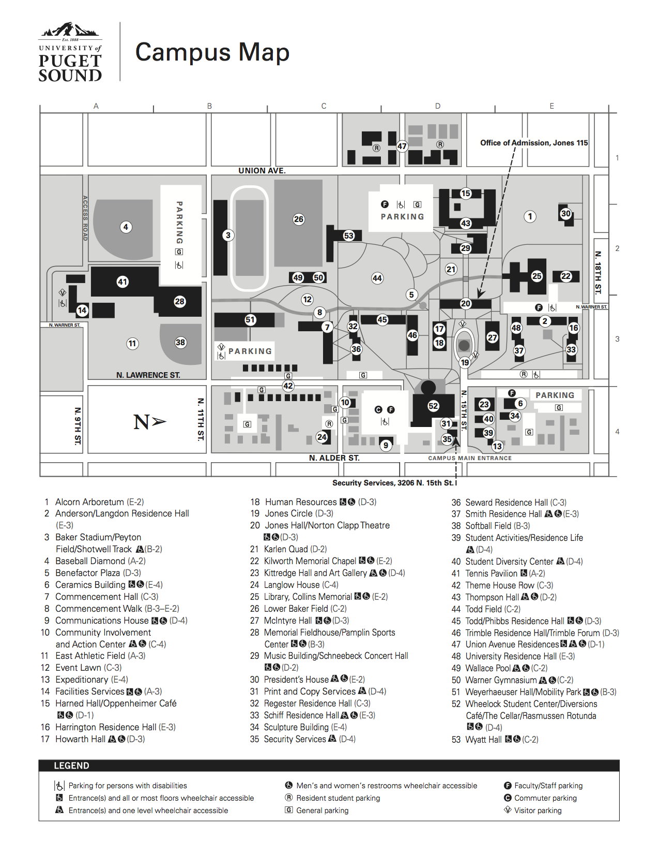

Restaurant/Grocery/Supply Place List (map at end of section for guidance)

Near Campus: Proctor (all centered around the Proctor area at N. 25th to N. 28th and Proctor)

Europa Bistro – Italian Cuisine with vegetarian and gluten free options. 3.5 stars on Yelp which might be generous.

East and West Café – Thai, Vietnamese, Noodles. 3.5 stars on Yelp. About right, mabe a little low.

Peaks and Pints – Beer bar with sandwiches and light fare. 4.5 stars on Yelp. 21+ only.

Starbucks – Also assume you know the drill. Mediocre coffee.

Safeway Grocery Store – also has a deli and a Starbucks.

Metropolitan Market Grocery Store – Nice grocery with large deli selection and many prepared food items. Also has barista and bakery. Expensive for a grocery store, but if you need cheese or that special heirloom orange, chances are they have it.

Viva 4 Life – Vegan and Raw. Limited hours.

Pomodoro – Italian. 3.5 stars on Yelp also about accurate, maybe high.

Waffle Stop – Breakfast and Brunch. 3.5 stars on Yelp. I’ve never been.

Top Pot – Donut shop. People seem to like it.

North 26th Street (from West to East beginning at 26th and Lawrence)

Rosewood Café – Neighborhood Café with sandwiches, salads, some pasta dishes, daily soup and rotating taps. Small, but friendly. 4 stars on Yelp.

Brewers Row – “New Mexican Cuisine. Counter service with a large tap selection and pretty good food. Vegetarian and Vegan options. 4 stars on Yelp.

Cooks Tavern – Sit down companion to Brewers Row, but with changing fare. Current cuisine focus is Barcelona/Spain. 4 stars on Yelp.

Mexi Tacos – Food truck at a gas station. 4.5 stars on Yelp.

6th Avenue (from West to East beginning at Union and 6th)

Farrelli’s Pizza – Pizza. 3.5 stars on Yelp.

Silk Thai Café – Thai food. 3.5 stars on Yelp.

Wild Orchid – Thai Food. 4 stars on Yelp. Probably better than Silk Thai.

Old Milwaukee Café – Hole in the wall breakfast spot. 4 stars on Yelp.

Red Hot – Hot Dogs and beer. 21+ kids love the place. 4.5 stars on Yelp.

E-9 – Local bar with “American traditional” food, e.g. burgers and nachos. 21 and under. 3.5 stars on Yelp.

Spanky Burger and Brew – haven’t been there. 4 stars on Yelp.

Taco Bell – Go ahead, try it if you want.

Original Pancake House – I assume they have pancakes. 3.5 stars on Yelp.

Asado – Argentinian food and a bit meaty. Also a bit fancier and pricier. 4 stars on Yelp.

El Borracho – Mexican. 4 stars on Yelp. Seems a bit high. 21+ only.

The Table – New American cuisine. Solid place with small and medium plates. but also 21+. 4.5 stars on Yelp.

Primo Grill – Mediterranean. Pretty good. A little pricier. 4 stars on Yelp.

Shakabrah Café – Traditional Breakfast/Lunch place with vegan/vegetarian options. Not fast. 3.5 stars on Yelp.

Gateway to India – Indian. 4 stars on Yelp.

Dirty Oscar’s Annex – American, Brunch, Gastropub. 21+ only. 4 stars on Yelp

MSM Deli – (Magic Sandwich Makers) – Also a favorite for to go sandwiches. 4.5 stars on Yelp.

Jack in the Box, KFC, A&W – See Taco Bell above.

Southern Kitchen – Local favorite of Southern food. 4 stars on Yelp.

Memo’s – Mexican fast food/take out. 3.5 stars on Yelp.

It’s Greek to Me – Greek fast food. 3.5 stars on Yelp.

Old Town (N. 30th at the bottom of the hill)

Montamara Kitchen – Breakfast/Brunch. Small spot. Good food. 4 stars on Yelp.

The Spar – Pub food. 3.5 stars on Yelp.

Starbucks – more coffee

Another coffee spot that changes its name every couple of months and I can’t keep up.

Ruston Way (moving East to Northwest)

Ram – Pub/American. 3 stars. Better than Applebees. 3 stars on Yelp. Good for a larger group.

C.I. Shenanigans – Seafood. Okay. 3 stars on Yelp.

Harbor Lights – Seafood. Local early bird special place that I believe makes a stiff cocktail. 3.5 stars on Yelp.

Katie Downs – Pizza. 21+. 3 stars on Yelp.

Lobster Shop – Seafood. 4 stars on Yelp. Pretty good.

Pt. Ruston (at the end of Ruston Way along the Water large area with restaurants, movie theater, condos)

Stack 571 – Burger and Whiskey Bar. 3.5 stars on Yelp. Might be better than that.

Wild Fin – Seafood and American. 3.5 stars on Yelp.

Farrelli’s Pizza – Another Farrelli’s if you’d rather eat by the water.

Fish Brewing Pub – Gastropub sort of place. New and working out some kinks. Better than the 2.5 stars on Yelp.

Jewel Box Café – Breakfast and brunch. 4 stars on Yelp.

Mio Sushi – Japanese. 3 stars on Yelp.

Ice Cream Social – Ice cream crafted in T-Town. Also have a location on 6th Ave.

Stadium/Wright Park (East of campus about a mile and a half)

Art House Café – Breakfast and Lunch. American New. 3.5 stars on Yelp but probably better.

Shake Shake Shake – Burgers and milkshakes. They do have the new Beyond Burger. 3.5 stars on Yelp.

Indo Asian Street Eatery – Asian Fusion. My personal favorite place in T-Town. 4.5 stars on Yelp.

Rhein Haus – German. Pretty meaty but has a couple of new vegetarian options. Bocce ball and games. 3.5 stars on Yelp. Probably good for a group.

The Hub – Pizza and new American. Pretty good and good for larger groups. 3.5 stars on Yelp.

Doyle’s Public House – Sandwiches. 21+. 4 stars on Yelp.

Hilltop (south East of Campus off MLK Jr. Way)

Le-Le -Vietnamese/Thai. 3 stars on Yelp, but probably better.

Pho King – Vietnamese. 4.5 stars on Yelp.

Quickie Too – Vegan/Vegetarian. Don’t let the name fool you. It is not fast, but it is so good. 4 stars on Yelp.

Additional Places. Mostly Downtown Area

Pacific Grill – Nice and good. Pricey, but solid food and fare.

Matador – Mexican Bar. 21+ only. Great nachos and good margaritas.

Old Spaghetti Factory – Italian (ish).

The Koi – Japanese and Sushi. 4 stars on Yelp.

The Rock Wood Fired Pizza – good pizza. 4 stars on Yelp.

El Gaucho – Steakhouse, if you like that sort of thing.

Melting Pot – Overpriced fondue.

Built – Variety food—sandwiches, salads, oysters inside Seven Sea’s brewery. Good food and fun place. Not speediest.

Supplies-paper, pens, etc.

Office Depot, Target, and Walmart are all located off of S. Union Street at about S. 19th to 23rd Streets. They are directly South of campus. Costco is located at S. 38th near I-5 and the Tacoma Mall.

The Tacoma Mall area and South I-5 also have a variety of restaurants. If you don’t see what you want, find me and I’ll try to help, but know fast food is not my specialty.

The map below should help out with some directions and specific locations.

