Dear Coaches,
You are cordially invited to attend the 2018 Kentucky High School Speech League state senior speech tournament to be held at the University of Kentucky, March 9 & 10, 2018. We will be using many places on the campus for our competition, so please prepare your students to become conversant with the map of the University.
We are working with the University currently to pin down details of parking and round timing, so please check the website closer to the tournament for specific information about these matters. Please read through all the information here carefully as your starting point for registration for this tournament.
1. Registration deadlines are firm. Entries for this tournament must be submitted by 5:00 PM Friday, February 23rd. This is the same deadline as the state debate tournament. Because there are many elements that must be determined based on entry numbers in every event, we must have complete, accurate entries at the deadline. We understand that emergencies happen, but it is vital that everyone confirm entries with students. The decision to attend and enter students must be made prior to deadline. Entry fees are $12 for each individual entry and $24 for each duo team entry.
2. The handbook contains extensive information about how the tournament is put together and how tabulation is done to determine advancement.
3. You may ONLY enter as many entries as you entered for regionals. If you applied for and were granted exemptions, these students are considered part of your roster for state. Students must have either attended the regional tournament or at a minimum two (2) KHSSL sanctioned tournaments to be eligible for the state tournament. As the coach, you will vouch for this qualification as a part of the KHSSL Code of Ethics.
4. The “registration deadline” for the tournament is the date by which you must have all your entries in – fees and judge obligations will be frozen on that date. You will be able to submit name changes of competitors or judges up until the change deadline which will be the Monday before the tournament, March 5. There will be no ADDS after the tournament registration deadline. Please double check your entry to be sure you have not left a student off who is eligible to attend. Drops after the initial registration deadline will be assessed a $10 nuisance fee plus forfeiture of the entry fee if reported before the Change Deadline of March 5. Drops reported at the tournament will incur a $50 drop fee. These penalties are set by the Board of Directors and are not at the discretion of any individual to waive. Please bring the funds necessary to fully pay your obligations for entries and drops to the tournament with you. Your students will not be allowed to compete if your fees are not paid in full.
5. Any schedules posted on the website are tentative until after the Change Deadline when we will know with complete certainty who is competing. When a final schedule is set, we will post it to the website and send out announcements via twitter and email.
6. Hotel information will be handled by Dustin Combs as has been done in the past. His email is dustin.combs@knott.kyschools.us.
7. In each speech event, you may have up to three (3) entries. Each individual student may enter up to three events. These entries DO NOT have to be the same students who competed in these events at the regional tournament. The students must be eligible for state competition. You do not have to enter students in the same categories as you did at regionals. The only restriction is TOTAL NUMBER of entries. This cannot exceed your regional total.
8. To verify student eligibility for competition at the state tournament, you will need to follow the procedures outlined below:
A. Register your team for state using tabroom.com.
B. Print a .pdf file of your registration entry by competitor
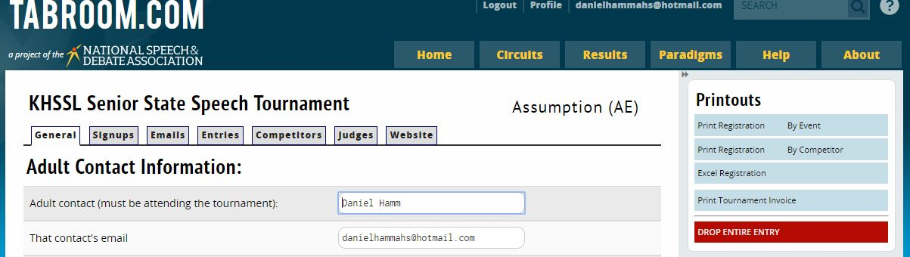

C. Email a copy of the .pdf file to Ryan Brown at ryan.brown@rowan.kyschools.us.
D. In this email, please include a list of KHSSL tournaments that your team attended during the season to aid in verification of eligibility. If you applied for and received exemptions for any students on your team, please include their names in the body of the email.

9. You are required to provide one (1) judge for every six (6) entries, or fraction thereof. So, if you have 7 entries total, you would be responsible for 2 judges. Purchasing a judge will incur a fee of $130.
10. Details regarding extemporaneous speaking topic areas, which events will clear to quarterfinals, etc. will be announced via the website, Facebook and Twitter closer to the tournament date.

If you have specific questions not addressed in this invitation, please contact Daniel Hamm at daniel.hamm@ahsrockets.org or Steve Meadows at steve.meadows@danville.kyschools.us.

