



Dear Forensic Moderators and Coaches:

The Lafayette College and the Phillipsburg High School Forensics Teams cordially invite you to the Lafayette Invitational on January 20, 2018, that will be held on the beautiful campus of Lafayette College in Easton, PA. We hope you can join us for an educational and enjoyable day of forensics competition.

We are offering 9 NCFL events (Dramatic Performance, Duo Interpretation, Oral Interpretation, Original Oratory, Extemporaneous Speaking, Declamation, Student Congress, Varsity and Novice Public Forum, and Varsity and Novice Lincoln-Douglas debate.

Declamation and Novice debate is only open to 9th or 10th graders in their first year of competing. Students may double enter in any of the speech events, but may not double enter if competing in student congress, LD or PF. There will be three preliminary rounds and a final round in all events, or 4 rounds, depending on the number of entries. In addition, we may collapse the debate divisions if there are not sufficient numbers to run the divisions separately. Awards will be presented to the top 2 schools and 3 finishers in each event, unless there are fewer than 5 competitors in the event and then only the top finisher will receive an award.

We hope to see you in a few weeks!

Laurie Schmid John Boyer
Forensics Coach Assistant Director of Forensics
Phillipsburg High School Lafayette College
Food: Students must bring their own food for the day. Food will NOT be available for purchase.
However, there will be food provided to judges.

Registration and Schedule: Registration will take place in the 1st floor lobby of the Simon Center and will begin Saturday at 8:00 am and continue until 8:45 am. We hope to begin Round 1 promptly by 9:15.

Drop-off Instructions: Students can be dropped off on S. College Drive, in between the Oechsle Center for Global Education and the Simon Center (GPS units can be directed to 30 S. College Drive, Easton, PA). There is a parking lot directly in front of the Simon Center with about 25 spaces for cars and vans. There are also some spots along S. College Drive if the lot fills up. There are no spaces for school buses. School buses will need to find street parking in the neighborhood around campus, along McCartney St., or at the bottom of S. College Drive, space permitting. Please see the included map for a more detailed map of relevant buildings. The green arrows show the best way to get to the Simon Center.

Directions to Lafayette College:
From the East: Take I 78 West to Exit 3. Exit on to Route 22 West and continue into Phillipsburg. Cross the Delaware River bridge and take the second exit immediately after crossing the bridge. This is Snyder Street and it will take you to a traffic light (3rd St.) Turn right and go up the hill on College Ave. Turn left on McCartney St and then Turn left on High St. and turn left on S. College Drive and the Simon Center will be on the right-hand side.
From the West and Pennsylvania: Take US 22 east to 4th Street Exit, Easton (marked for Lafayette College). At the foot of the ramp, turn left, and then left again at first stop light (Third Street, then College Avenue). At the top of the hill, take the first left (McCartney Street). Turn left at the first stop sign (High Street) and then turn left onto S. College Drive, and the Simon Center will be on the right-hand side.

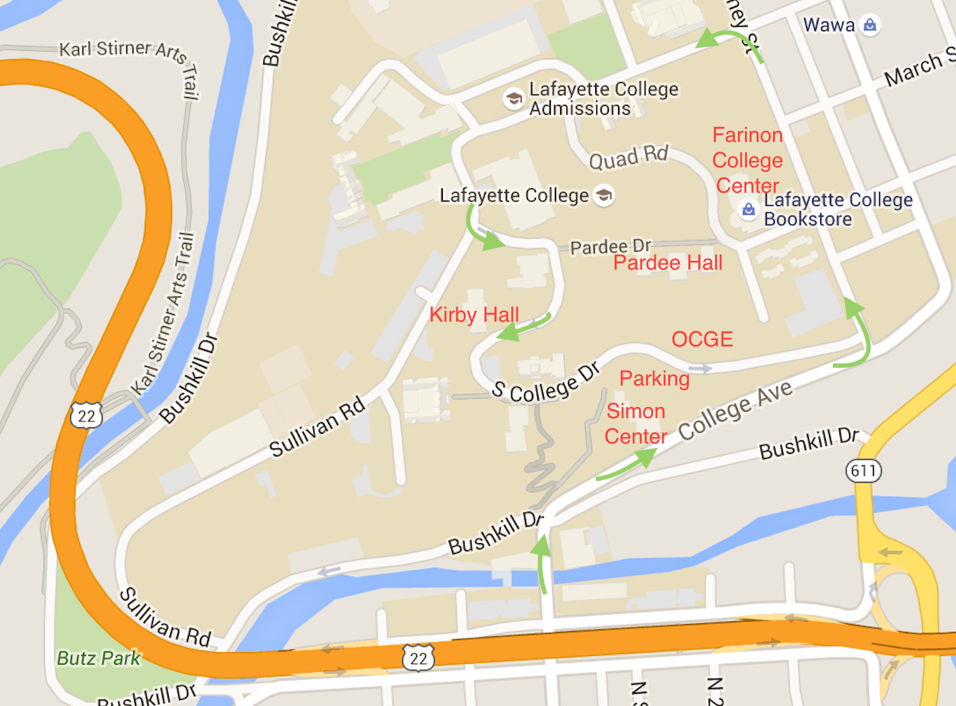

Events: Student Congress Declamation
Extemporaneous Speaking Duo Interpretation
Original Oratory Dramatic Performance
Oral Interpretation
Public Forum Debate (Varsity & Nov.) Lincoln-Douglas Debate (Varsity & Nov.)

Resolutions:

In Lincoln-Douglas debate students will be debating the January/February resolution:

Resolved: Plea bargaining ought to be abolished in the United States criminal justice system.

In Public Forum students will be debating the January resolution:

Resolved: Spain should grant Catalonia its independence.

Congress: Please submit all Congress bills to fraulaurie@hotmail.com by Friday, January 12, 2018. They will be uploaded to tabroom by Saturday, January 13, 2018.

Competition Space: Please do your best to keep classrooms clean and organized. The tournament weekend is one of the days that Lafayette students will be moving back to campus. There will be parents and students around campus on Saturday. Please be respectful of your surroundings and the facilities.

Public and Shared Spaces: The lobbies of Pardee Hall and the Simon Center will be available as congregation spaces for your teams to gather. A few classrooms in Pardee Hall will also be designated for this purpose.
Entry Deadline: Entries are due by Wednesday, January 17, 2018. Registration will be done online at www.tabroom.com. Adds and drops can be made without penalty on the website until 3:00 p.m. on Friday, January19. A nuisance charge of $5 will be made for any drops and adds made after this time. Dropped judges will incur a $125 penalty. A waitlist will be utilized so that competitors from all schools can be accommodated in the space available.

Judges: One judge per five speech contestants, one judge per every three PF debate teams, and one judge per every three LD debaters or fraction thereof is required. If you drop contestants on the day of the tournament, judges still must be provided for those dropped slots. Dropped judges after 3 pm on Friday, Jan. 19th will result in a $125.00 dropped judge penalty fee. A very limited number of hired judges will be available. Please make every effort to bring your own judges and stress to all of them that they must remain for the entire tournament. All judges must be available to judge the final round of any event. A judges training meeting will be held before the start of round 1.

Hired judges may be hired for $90.00 per judge on a first come, first serve basis. Deadline for Judge Requests: Tuesday, January 16, 2018.

Awards: The top 3 competitors advancing to the final round and the top three schools will receive awards (unless there are fewer than 5 and then only the first-place finisher will receive an award).

Fees: You must present payment in the form of cash, check, or purchase order on the day of the tournament. We will not bill your school for the amount due.

Individual Speakers (including congress)
LD Debaters
PF and Duo Entries
Hired Judges
Nuisance Fees (after 3 pm Friday)
Dropped Judge Penalty

$8.00 per slot
$10.00 per slot
$12.00 per slot
$90.00 per judge
$5.00/ drop and $5.00/add
$125.00

Please make checks/purchase orders payable to: Phillipsburg Forensics Team

Anything Else? Questions can be directed to Laurie Schmid at (908) 454-3400 Ext. 7881, cell (908)619-1812, home (908) 859-2885 or fraulaurie@hotmail.com. For Lafayette specific inquiries, you can reach John Boyer at lafayettedebate@gmail.com.

