North Catholic
Tournament

Congress Legislation
2017

A Resolution to Formally Declare Support for the Kurdish People #1

- WHEREAS, The Kurdish People were promised land by the Western Allies (including the United States) after World War One in the 1920 Treaty of Sevres; and
- WHEREAS, This was later contradicted in the Treaty of Lausanne, in which the modern borders of Turkey were set; and
- WHEREAS,The Kurdish people were left with nowhere to go, but have the highest concentration in Turkey, making up approximately 25% of the population; and
- WHEREAS, In Turkey, the Kurds have experienced nothing but oppression and mistreatment; and
- WHEREAS, The United States must not fall back on the promise they made to give land to the Kurds, especially given the continued support received from the Kurds.
- THEREFORE BE IT RESOLVED, That the Student Congress here assembled recommend the formal declaration of support of Kurdish people and their efforts to receive land. This could include the introduction of legislation United Nations or any other means of physical support.

Respectfully submitted by
Our Lady of the Sacred Heart High School

A Resolution to Require Schools to give Mandatory Standardized Test Preparation #2
- WHEREAS, The United States lags behind other nations in math, science, and reading.
- WHEREAS, According to Programme for International Student Assessment (2015), The U.S. is ranked 38th out of 71 countries in math and 24th in science.
- WHEREAS, 47 percent of students are underprepared for standardized tests in high school.
- WHEREAS, More students will be inclined to take standardized tests if given more practice and resources.

- RESOLVED, that the student congress here assembled require schools to give mandatory Standardized Test preparation.

Respectfully Submitted,

Moon Area High School

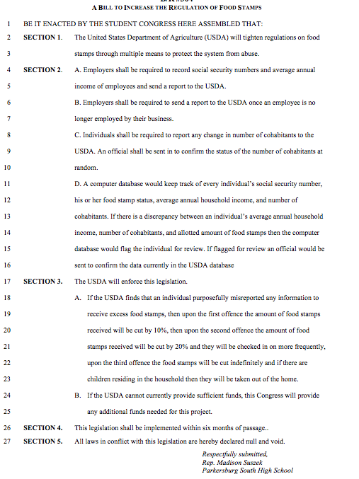
A BILL TO DRUG TEST RECIPIENTS OF FEDERAL PUBLIC ASSISTANCE #4

BE IT ENACTED BY THIS CONGRESS THAT:

1 SECTION 1 Random drug tests for illegal substances will be required twice yearly for all

2 recipients or beneficiaries of public assistance, age 18 or older, whose income is

3 derived, directly or indirectly, from Federal funds.

4 SECTION 2 Public assistance payments to the household will be reduced by 25% for each

5 person in that household who tests positive for illegal substances and who does

6 not enter a treatment program within 7 days after testing positive.

7 SECTION 3 This legislation will take effect six months after enactment.

Respectfully Submitted,

Quigley Catholic High School

