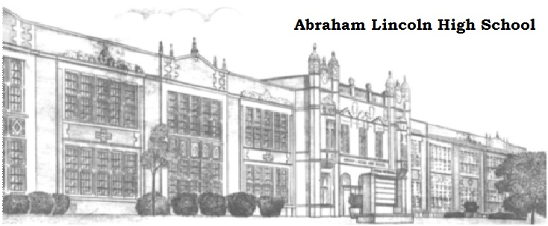

Speech and Debate Colleagues,
We would like to invite you to the 2017 Lincoln High School Railsplitter Speech and Debate Tournament. The Railsplitter will run Friday, December 15th and Saturday, December 16th. All teams, both in-state and out-of-state schools, are welcome to participate.
All speech events will be held on Friday, December 15th. All debate events will be held on Saturday, December 16th.
We will offer the following speech and debate events:
Speech - DI, HI, POI, OO, Poetry/Prose, Spontaneous Speaking, Duo, Mixed Extemp, and Informative.
Debate - PF (varsity and novice divisions if possible), and Congress (open division).
WE WILL OFFER THE JANUARY NSDA TOPIC IN PUBLIC FORUM DEBATE. The Railsplitter is one of the only opportunities in the area to use the January topic prior to the IHSSA State Debate Tournament, so is a wonderful opportunity to prepare for that event.
We appreciate your support and welcome any questions that you may have. Please don’t hesitate to contact me at kaitlyn.evans@dmschools.org or (515) 242 7528. We look forward to seeing you and your teams in December!
Kaitlyn Evans
Speech and Debate Coach
Abraham Lincoln High School
Des Moines, IA

ENTRY DEADLINES: Please have your entries in Tabroom by Tuesday, December 12th at 5:00 PM. Fees will be assessed for dropped entries after this time.
Fees and judging obligations will be frozen on Tuesday, December 12th at 5:00 pm.
Judge entries are due by Wednesday, December 13th at 5:00 PM.
Online drops/name changes will be accepted until 5:00 PM on Wednesday, December 13th.
ENTRY FEES: The following are the entry fees for the Railsplitter:
$15.00 per Speech entry
$15.00 per Congress entry
$30.00 per Public Forum entry
MAKE CHECK PAYABLE TO: Lincoln High School Debate
Send payment to: Lincoln High School Debate c/o Kaitlyn Evans
2600 SW 9th Street, Des Moines, IA 50315

JUDGING OBLIGATIONS: Judging obligations are as follows:
Speech: one judge is required for every six speech entries.
Congress: one judge is required for every eight congress entries.
Public Forum: one judge is required for every two PF teams.
A VERY limited number of judges will be available for hire. Please do what you can to fill your judging requirements.
Requests to hire judges must be made via email to kaitlyn.evans@dmschools.org before Wednesday, December 6 at 3:00 PM. Requests to hire judges will be confirmed via email as they are received. A hired judge is not guaranteed until you receive a conformation email.
HIRED JUDGE FEES: | $100.00 per Speech Hired Judge
$100.00 per Congress Hired Judge
$100.00 per Public Forum Hired Judge

NO SHOW JUDGE PENALTY: If you have a judge who fails to show up at the tournament, you will need to provide a replacement judge or pay the corresponding hired judge fee (if additional hired judges are available). If you cannot provide a replacement judge and there are no remaining hired judges available, students may be dropped from competing and you will be charged any resulting drop fees.

