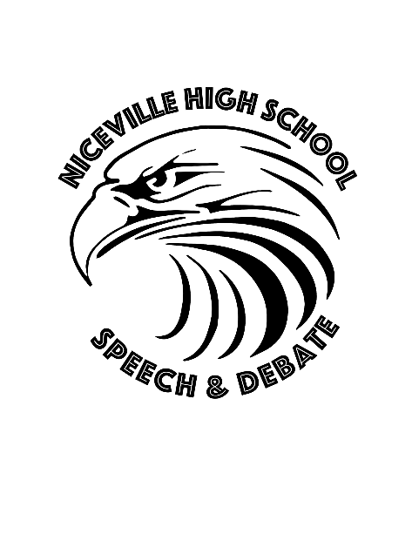
NICEVILLE Forensics NSDA BIG QUESTION DEBATE
Friday, 20 October 17 4-8 PM Students gather in café; judges in media center
Send in competitors’ names NLT 19 Oct. to buisp@okaloosaschools.com
&

NICEVILLE Forensics FFL INVITATIONAL
Speech & Debate Tournament
Saturday, 21 Oct 17 8 AM -5 PM Students gather in café; judges in media center
Speech events: DI, HI, OO, Dec, USX, POI
Debate events: PF, CD, LD
Entry fee $25.00
Chick-Fil-A box lunch included orders due NLT Monday, 16 Oct. 17
Please specify number of vegetarian meal options. A nut-free room will be available for lunch.
Gulf Breeze High School’s Homecoming was moved due to Hurricane Nate, so they may be leaving before awards; please have someone designated to take awards.
CD Legislation due Friday, 13 October email to buisp@okaloosaschools.com

