Dear Debate Coaches,
Roseville Area High School is pleased to be offering our invitational classic debate tournament on Friday and Saturday October 27 and 28, 2017. This is the twelfth annual Roseville Rosebowl. The tournament will follow a bowling theme with awards for the top three two person teams winning bowling pins as trophies. We expect these to become coveted keepsakes.
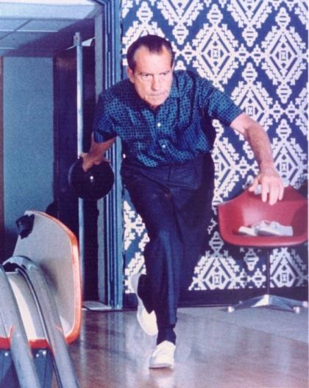
Policy and LD Debate: We offer three divisions: Varsity, JV, and Novice. All debaters will debate on the following resolutions:
LD: Resolved: In the United States, national service ought to be compulsory.
Policy: Resolved: The United States federal government should substantially increase its funding and/or regulation of elementary and/or secondary education in the United States.
Judges: You must provide one qualified judge for every two teams entered. We will provide a short meeting before the tournament starts to provide an overview of the process of judging. Judges will be fed.
Registration: Please register by e-mail. The registration deadline is WEDNESDAY, October 25. To register, please use tabroom.
For judges, please indicate the divisions that they are qualified to judge.
Food: Pizza, pop and candy will be available for sale at lunch time.
Fees: The cost is $25 per two-person team, checks payable to Roseville Area High School Debate. Novice and Rookie Policy teams can register for Friday and/or Saturday for 12 dollars each.
Brian Plunkett Memorial Award: This is the second year that we will be recognizing the most creative argument delivered in a debate round during the tournament. THis is a special award to honor our former coac, Brian Plunkett who passed away in 2016.

We hope you can attend this tournament.

Gregg Martinson
Tournament Director

