A Bill to Establish a Cap-And-Trade Program

1 BE IT ENACTED BY THE STUDENT CONGRESS HERE ASSEMBLED THAT:
2 Section 1. The United States implement a nationwide corporate cap-and-trade
3 program with the goal of reducing greenhouse gas emissions.
4 Section 2. The cap is defined as a limit on greenhouse gas emissions. The trade
5 allows companies to buy and sell allowances of emissions. The goal is that
6 companies are incentivized to cut emissions to save money.
7 Section 3. The Environmental Protection Agency shall be responsible for overseeing
8 and enforcing this legislation.
9 A. The program would establish a cap on greenhouse gas emissions for
10 individual corporations. The corporations may sell their unused allowance
11 to other corporations, if desired. Companies must use profits made from
12 selling these allowances to either invest in green energy or give relief to
13 their customers.
14 B. The amount of the cap will be set each year according to the nationwide
15 goal set forth by the Paris Climate Accord of cutting total greenhouse gas
16 emissions by 26% by the year 2025.
17 Section 4. This legislation shall take effect January 1, 2018.
18 Section 5. All laws in conflict with this legislation are hereby declared null and void.

Introduced by
Senator Correna Tate
Assumption High School

A Bill to Increase Carbon Taxes
1 BE IT ENACTED BY THE STUDENT CONGRESS HERE ASSEMBLED THAT:
2 Section 1. The tax levied on the carbon content of fuels be increased by the United
3 States federal government.
4 Section 2. A carbon tax is a tax levied on the carbon content of fuels and a form of
5 carbon pricing. Carbon is present in coal, petroleum, and natural gas, and
6 converted to carbon dioxide (CO. 2) and other products when combusted.
7 Because the tax makes using dirty fuels more expensive, it encourages utilities,
8 businesses and individuals to reduce consumption and increase energy efficiency.
9 Section 3. The Environmental Protection Agency shall be responsible for overseeing this
10 legislation, and the United States Federal Government shall be responsible for
11 enforcing this legislation.
12 Section 4. This legislation shall take effect upon passage.
13 Section 5. All laws in conflict with this legislation are hereby declared null and void.

Introduced by
Senator Kennedy Nodler
Assumption High School

A Bill to Legalize Hemp
1 BE IT ENACTED BY THE STUDENT CONGRESS HERE ASSEMBLED THAT:
2 Section 1. The production and sale of industrial hemp shall be decriminalized by the
3 United States federal government.
4 Section 2. Hemp is any variety of the cannabis plant that has tetrahydrocannabinol levels
5 of below 0.3%. The plant is bred for its fibers and does not have narcotic abilities.
6 Section 3. The Drug Enforcement Administration shall be responsible for overseeing
7 and enforcing this legislation.
8 Section 4. This legislation shall take effect upon passage.
9 Section 5. All laws in conflict with this legislation are hereby declared null and void.

Introduced by
Senator Correna Tate
Assumption High School

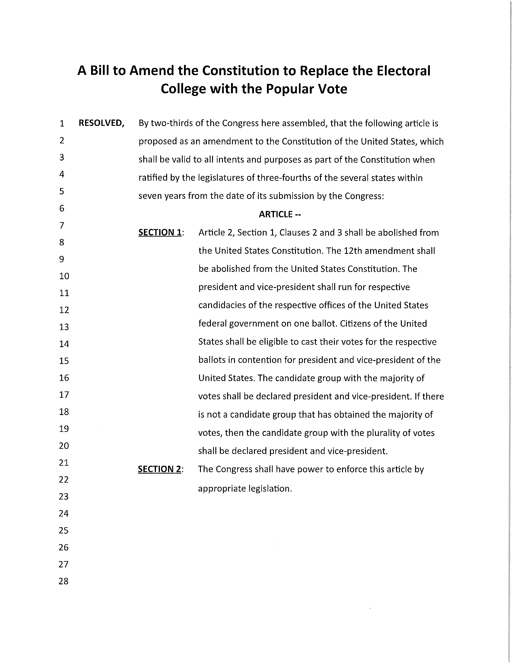
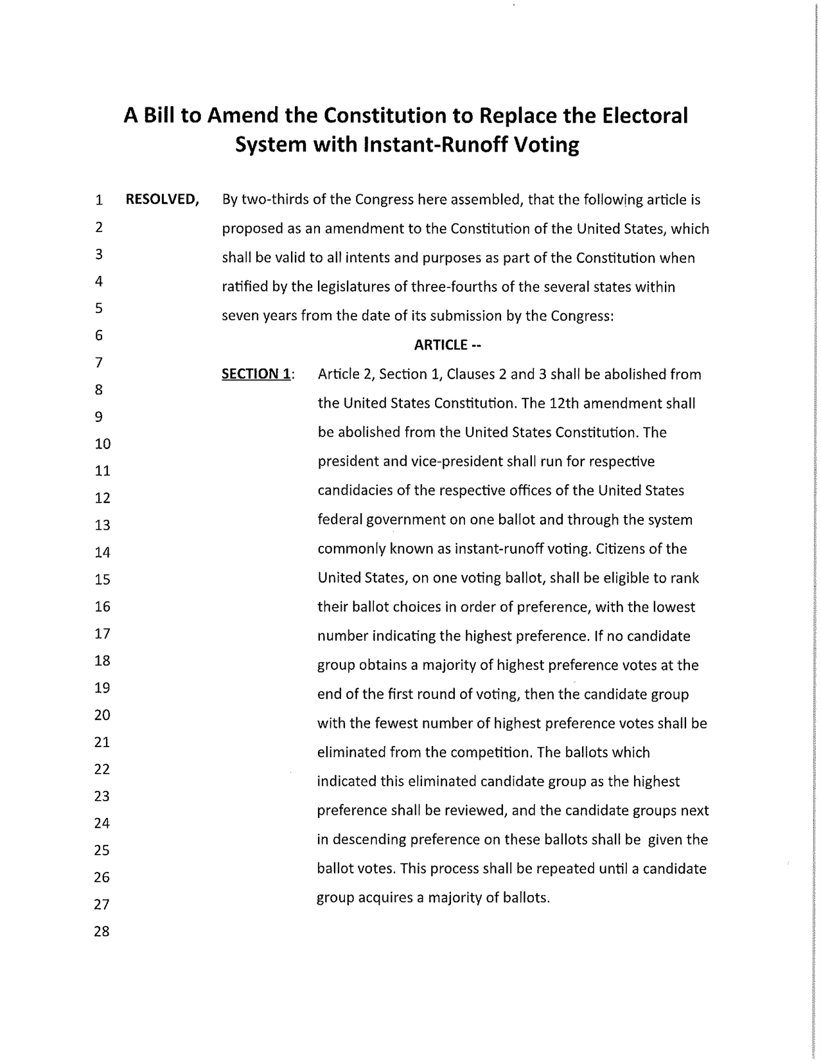
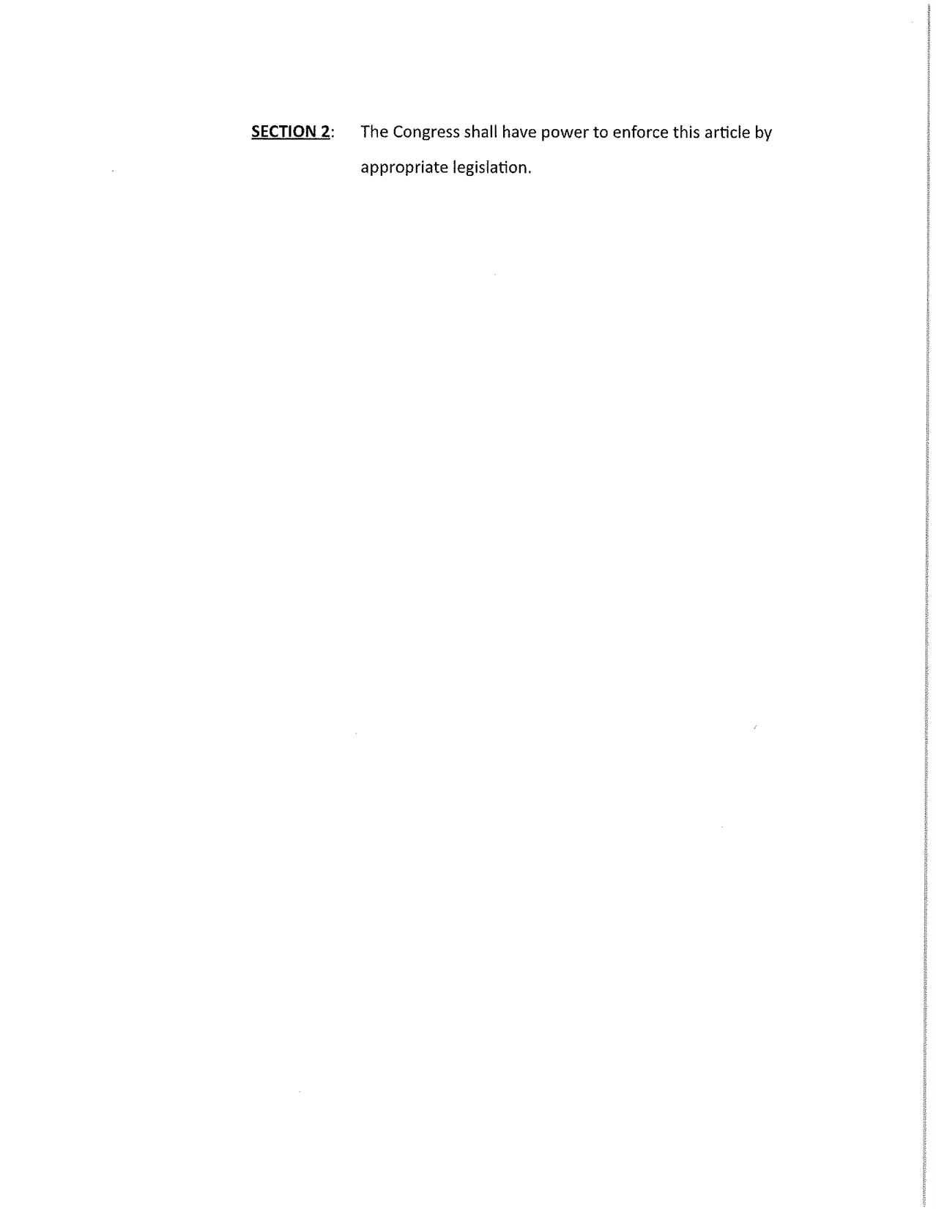
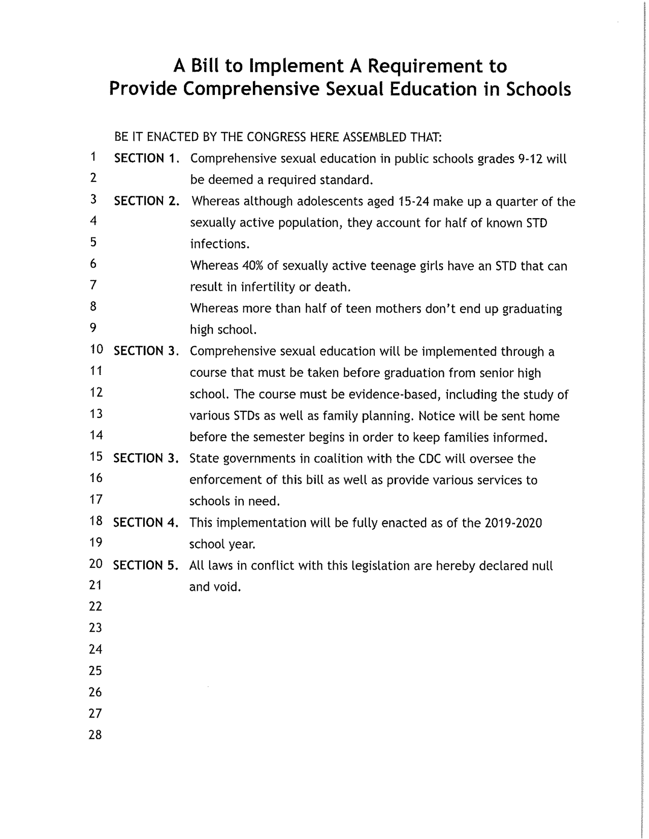
A Resolution to Support the Creation of a Kurdish State in Northern Iraq
1 WHEREAS, A Kurdish referendum has recently shown that the vast majority of the Kurdish people in
2 Iraq wish to break away from the control of Baghdad; and
3 WHEREAS, They have fought for their independence repeatedly for years; and
4 WHEREAS, Continued subjugation of the Kurdish people will cause more strife in the Middle East;
5 and
6 WHEREAS, It would be in our best interest to promote a more stable Middle East by supporting the
7 creation of Kurdistan in Northern Iraq; now, therefore, be it
8 RESOLVED, That the Congress here assembled make the following recommendation for the United
9 Federal Government to support the creation of Kurdistan and use of diplomatic means to accomplish
10 said task peacefully.

Introduced for Congressional Debate by Cooper Winrich from Trinity High School.

A Bill to Ban Direct-to-Consumer Advertising of Prescription Drugs

1  2  3  4  5  6  7  8  9  10  11  12  13  14  15  16  17  18  19  20  21  22  23  24  25  26  27  28 | BE IT ENACTED BY THE CONGRESS HERE ASSEMBLED THAT:  SECTION 1. Direct-to-Consumer drug advertisements shall hereby be banned on television and radio.  SECTION 2. Direct-to-Consumer drug advertisements are defined as a form of promotion that is aimed toward patients or consumers rather than healthcare professionals.  SECTION 3. The Food and Drug Administration shall be in charge of overseeing the implementation of this legislation.  SECTION 4. This legislation will take effect 180 days after passage.  SECTION 5. All laws in conflict with this legislation are hereby declared null and void.
Introduced for Congressional Debate by Trinity High School.

A Bill To The Ban The Creation Of The Keystone XL Pipeline

1 BE IT ENACTED BY THIS CONGRESS THAT
2 Section 1: This bill will revoke the permit given to TransCanada to construct the Keystone XL Pipeline.
3 Section 2: The Keystone XL Pipeline is the proposed TransCanada crude oil pipeline expansion
4 on the current Keystone Pipeline.
5 Section 3: No funding will be necessary for this bill.
6 Section 4: This bill will be made effective immediately after passing.
7 Section 5: All other laws that are in conflict with this legislation shall hereby be declared null
8 and void.

Respectfully Submitted by
Christian Butterfield,
Bowling Green High School

A Bill To Abolish The Use Of Capital Punishment
1 BE IT ENACTED BY THIS CONGRESS THAT
2 Section 1: The use of capital punishment in the United States will be abolished and all who are
3 currently on death row will have their sentence commuted to life in prison.
4 Section 2: Capital punishment is defined as the execution of criminals as retribution for their
5 crimes.
6 Section 3: The Department of Justice will oversee both the enforcement and the timely
7 awareness of this bill by prison officials. No funding is required for this bill.
8 Section 4: This bill will be made effective immediately after its passing.
9 Section 5: All other laws that are in conflict with this legislation shall hereby be declared null
10 and void.

Respectfully submitted by,
Christian Butterfield,
Bowling Green High School

A Bill to Provide Oversight to the Federal Election Process

1 BE IT ENACTED BY THE CONGRESS HERE ASSEMBLED THAT:
2 SECTION 1. All elections for federal offices shall be administered by a Committee for
3 Federal Elections. This Committee shall standardize procedures for all elections of
4 federal officials across the country.
5 SECTION 2. The Committee shall bear responsibility for the following:
6 A. Creating standards for and verifying voter eligibility for federal
7 elections
8 B. Identifying polling locations
9 C. Hiring and training poll workers
10 D. Procuring and testing technology for electronic balloting
11 E. Collecting, verifying, and ratifying election results.
12 SECTION 3. The Department of Justice will oversee the creation of the Committee for
13 Federal Elections. The chair of the Committee shall be appointed by the
14 president, with the advice and consent of the Senate.
15 SECTION 4. This committee shall be in place by January 2018
16 SECTION 5. All laws in conflict with this legislation are hereby declared null and void.
Respectfully submitted by,
Ronit Patel,
Bowling Green High School
A Bill to Halt Arms Sales to Saudi Arabia

1 BE IT ENACTED BY THE CONGRESS HERE ASSEMBLED THAT:

2 SECTION 1: The United States shall halt future arms sales to the Kingdom of Saudi Arabia.
3 SECTION 2: Arms sales shall be defined as the trade or sale of weaponry and ammunition, including battle tanks
4 and machine guns.
5 SECTION 3: The State Department and Department of Defense are responsible for the enforcement of this
6 legislation. Failure to comply with this legislation will result in a budget cut of twenty five percent of the
7 responsible department.
8 SECTION 4: This bill will go in effect on January 1, 2018.
9 SECTION 5: All laws in conflict with this legislation are hereby declared null and void.

Respectfully submitted by,
Ronit Patel,
Bowling Green High School

A Bill to Ban Unfermented Soy

1 BE IT ENACTED BY THE STUDENT CONGRESS HERE ASSEMBLED THAT:

2 SECTION I: This legislation would cease the use of unfermented soy as a food additive in the
3 United States.
4 SECTION II: Unfermented soy is a product of soy that has not undergone a chemical transformation
5 known as “fermentation.” Fermented soy is a soy product that has gone through the lengthy chemical
6 process.
7 SECTION III: The FDA will oversee the implementation of this regulation.
8 SECTION IV: This legislation will be put into effect on January 1st 2021.
9 SECTION V: All other laws in conflict with this new policy shall hereby declared null and
10 Void.

Respectfully submitted,

Zachary Martin,
Bowling Green High School

A Bill to Legalize Medicinal Marijuana in the United States to Treat Those With Chronic Pain and High Stress Levels
1 BE IT ENACTED BY THE CONGRESS HERE ASSEMBLED THAT:
2 Section 1. Marijuana shall be legalized for its medicinal qualities in order to treat minor symptoms on a
3 federal level.
4 Section 2. Medicinal - having healing properties Minor Symptoms - pain, anxiety, restlessness,
5 migraines, headaches, etc.
6 Section 3. The FDA will carry out any and all regulations in regards to the substance.
7 Section 4. This Bill is to be put in place by December 31st, 2017.
8 Section 5. All laws in conflict with this legislation are hereby declared null and void.

A resolution to impose more sanctions on Iran
1 Whereas, Iran is continuing to go forward with its nuclear program despite the United States threatening
2 consequences if they continue to go on with developing any missiles that could potentially carry nuclear
3 warheads.
4 Whereas, many U.S allies in the middle east are threatened with the development of Iranian nuclear
5 missiles. These allies include but are not limited to Saudi Arabia, Turkey, United Arab Emirates, and
6 especially Israel.
7 Whereas, Iran has many anti United States allies in the region that the United States already has
8 sanctions put in place against. These allies include Russia, Syria and North Korea. All of which are very
9 anti United States
10 Whereas, Iran has been very anti U.S. every since the Iranian revolution of 1979, the leaders and citizens
11 of the country have been known to chant “death to america”, and American citizens are targeted, hence
12 the iranian hostage crisis between 1979 to 1980.
13 Therefore be it. Resolved, that the United States impose numerous new sanctions with Iran. These new
14 sanctions will include having a travel ban for U.S citizens to visit Iran. It also forbids any American
15 Businesses from investing in Iran.

A bill to send hurricane relief funds to Puerto Rico.
1 Be it enacted by the Congress assembled by
2 Section 1. The United States federal government will send 1 billion dollars in relief to Puerto Rico,
3 which was recently hit by Hurricanes Irma, Jose, and Maria. The money needed will be obtained by
4 cutting the United States defense budget by 1 billion dollars.
5 Section 2. The relief coming to Puerto Rico includes 50 million dollars worth of water bottles, blankets
6 and clothes, beds for refugee shelters, and food packages as well. The other 50 million dollars will be
7 used for repairing Puerto Rican infrastructure and draining excess water from populated areas.
8 Section 3. The Federal Emergency Management Agency will oversee the enforcement of legislation.
9 The funds will be sent through FEMA to the Puerto Rican Government,
10 where the Department of Transportation and Public Works will oversee the legislation from Puerto Rico
11 Section 4. This bill will be put into effect immediately after its passing
12 Section 5. All laws in conflict with this piece of legislation are hereby declared null and void.

Submitted by Ryle High School

A Bill to Legalize and Impose a Sales Tax on Recreational Marijuana

1 BE IT ENACTED BY THE CONGRESS HERE ASSEMBLED THAT:
2 SECTION 1 . Recreational Marijuana will be legalized in all 50 states for those ages 21 and over.
3 Once upon legalization, a Sales Tax will be placed upon recreational marijuana in all forms. Effects of
4 this bill also include that all people convicted of minor marijuana possession charges will have their
5 cases reviewed for dismissal by the Department of Justice (DOJ). In the case of a dismissal by the DOJ,
6 the individual will have his or her charges on minor marijuana possession expunged from their police
7 record.
8 SECTION 2 .
9 A. Recreational Marijuana should be defined as Marijuana used without medical justification.
10 B. Sales Tax should be defined as a tax imposed by the Federal Government on the sale of goods
11 and services, levied at the point of sale, collected by the retailer and passed on to the Federal
12 Government.
13 SECTION 3 . The Food and Drug Administration will oversee the regulation of the sale of recreational
14 marijuana. The Internal Revenue Service (IRS) will implement and enforce the sales tax. The
15 Department of Justice will review the cases of those incarcerated under minor marijuana charges for
16 dismissal.
17 SECTION 4. This bill will take effect on November 20, 2017
18 SECTION 5. All laws in conflict with this legislation are hereby declared null and void.

Introduced for Congressional Debate by Ryle High School.

A Bill to Replace Lead Paint from Households Across America
1 Be it enacted by the Congress assembled
2 SECTION 1. Be it enacted that lead paint will be removed from lower income households across the
3 country will be removed.
4 SECTION 2. A lower income household is any household in the U.S. that makes less than $53,718
5 according to the U.S. Census Bureau. According to a survey by the Department of Housing and Urban
6 Development 1.1 million lower income households across america have lead paint.
7 SECTION 3. The agency of Housing and Urban Development and EPA will hire lead-safe contractors
8 that will oversee the implementation and removing of lead paint. Congress will provide the HUD Office
9 of Lead Hazard Control & Healthy Homes with twenty billion dollars in funding for this program.
10 SECTION 4. This shall take effect a year upon passage.
11 SECTION 5. All laws in conflict with this legislation are hereby declared null and void.

