A Resolution to Provide Free Tuition to Public Universities
- WHEREAS, current student loan debt in America exceeds $1 trillion, causing a fiscal bubble that will eventually burst, crippling the American Economy.
- WHEREAS, the average college graduate in America is in $30,000 in debt when they graduate college, inhibiting potentially economically stimulating entrepreneurial activity from recent college graduates.
- WHEREAS, public universities operating on taxpayer dollars should not charge students for an education as this infringes upon the principle of equality of opportunity that America is based upon.
- WHEREAS, the current rate at which public university tuition increases in the United States makes it so that most families have no ability to support their college students, forcing the full burden of debt upon the students themselves.
- WHEREAS, the current system of federal student aid (FAFSA) inadequately provides sufficient financial aid to middle class students in America and should be dissolved.
- WHEREAS, students cannot declare bankruptcy on student loans, an absurd practice that ensures the failure of graduates who cannot pay back loans soon enough.
- WHEREAS, current students in America who work hard to sustain admirable success in high school deserve to have their efforts rewarded.
- WHEREAS, all laws in disagreement with this bill will be null and void from the date of its passing.
THEREFORE BE IT RESOLVED, By the Congress here assembled that all tuition for public colleges and universities in America should be free to students who graduate high school with an unweighted GPA of 3.5 or above.

Respectfully Submitted
Josh Frederick & Josh Bray
Karns City High School
A Bill to Raise the Minimum Wage in Pennsylvania

BE IT ENACTED BY THE STUDENT CONGRESS HERE ASSEMBLED THAT:
Article I: The now minimum wage in the state of Pennsylvania ($7.25) will be raised to $8.50.
  - Article II: Minimum Wage: the lowest wage permitted by law or by a special

agreement (such as one with a labor union).

Article III: This bill will take full effect on January 1st, 2020.
Article IV: The Wage and Hour Division of the U.S. Department of Labor is responsible for enforcing the minimum wage. Using both enforcement and public education efforts, the Wage and Hour Division strives to ensure that workers are paid the minimum wage.
Article V: All laws in conflict with this new policy shall hereby declared null and void.
Respectfully submitted,
Michael Drambel

A BILL TO REQUIRE NEWS AGENCIES TO REFRAIN FROM BROADCASTING PRESIDENTIAL PROJECTIONS UNTIL THE LAST POLLING STATION CLOSES
SECTION 1: Definitions
- “Presidential projection” is defined as any action, undertaken by a news agency, which in any way may skew voting patterns in later-voting states, and is any action, undertaken by a news agency, which involves using exit polls and other data sources to predict the outcome of the US Presidential Election.
- “News agency” is defined as any organization that uses print, television, radio, Internet, or other mediums to publish news.
- “Polling Station” is defined as a location where votes are cast by voting machine, voting tablet, paper ballot, or other officially sanctioned tabulation devices.
SECTION 2: Legislation
- Absentee ballots are not included in the definition of “polling station.”
- News agencies shall not be allowed, under penalty of law, to broadcast or suggest presidential projections until the last polling station closes.
- The FBI is tasked with observing for this hereby illegal behavior, and prosecuting the offender(s) in the nearest federal district court.
SECTION 3: Passage
- This bill shall go into effect on November 8th, 2016.
- Respectfully submitted by USC High School.

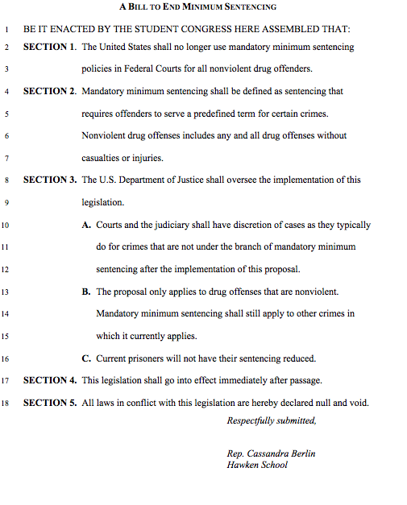

A Bill to Protect Consumers from Banks
1 BE IT ENACTED BY THE CONGRESS HERE ASSEMBLED THAT:
2 SECTION 1. Banks and investment firms shall be prohibited from using consumer
3 agreements requiring arbitration for future disputes or limiting the
4 consumer from participating in a class action concerning a covered
5 consumer financial product.
6 SECTION 2. “Consumer financial product” shall be defined as any product or service
7 offered by a bank or investment firm for the benefit of one or multiple
8 customers.
9 SECTION 3. The Bureau of Consumer Financial Protection shall be responsible for the
10 implementation of this legislation.
11 SECTION 4. This legislation shall take effect immediately upon its passage. Any
12 agreements containing a clause restricted by this legislation shall remain
13 in effect, however, the specific clause shall be nullified. Banks and
14 investment firms must notify all customers of this change to their
15 agreement within thirty (30) days of the passage of this legislation.
16 SECTION 5. All laws in conflict with this legislation are hereby declared null and void

