You are invited to the
Cache Classic

The Cache County Speech and Debate teams from Green Canyon, Mountain Crest, Ridgeline, and Sky View would like to invite you to our tournament held on Saturday, November 18th 2017.

Location: Ridgeline High School, 180 N. 300 W., Millville, UT 84326

Divisions: We will offer a Novice division and an Open division. Please note the available events for each division.

Novice
Public Forum Lincoln Douglas (varsity topic)
Policy

Open
Policy Debate
Public Forum
Lincoln-Douglas
Congress
National Extemp
Foreign Extemp
Original Oratory
Impromptu
Storytelling
SPAR-formal/academic
topics

Humorous Interp Dramatic Interp Duo Interp

Double Entry –Students entered in debate, congress or extemp events may NOT double enter. Students entered in speech events may double enter at their own risk. NO TRIPLE ENTERING.

Congress – The docket and Orders of the Day will be sent out a few weeks prior to the tournament.

Public Forum – Resolved:

Lincoln-Douglas – Resolved:

Awards – Trophies for 1st, 2nd, and 3rd in every event, sweepstakes, AND a special coaches award.

Dress – Competitors are encouraged to embrace our Modern-day Mountain Man theme by wearing their cheesiest outdoor t-shirts. This theme has mostly derived from our grief over losing the Halloween dress up and our current state of mind: not giving a crap.

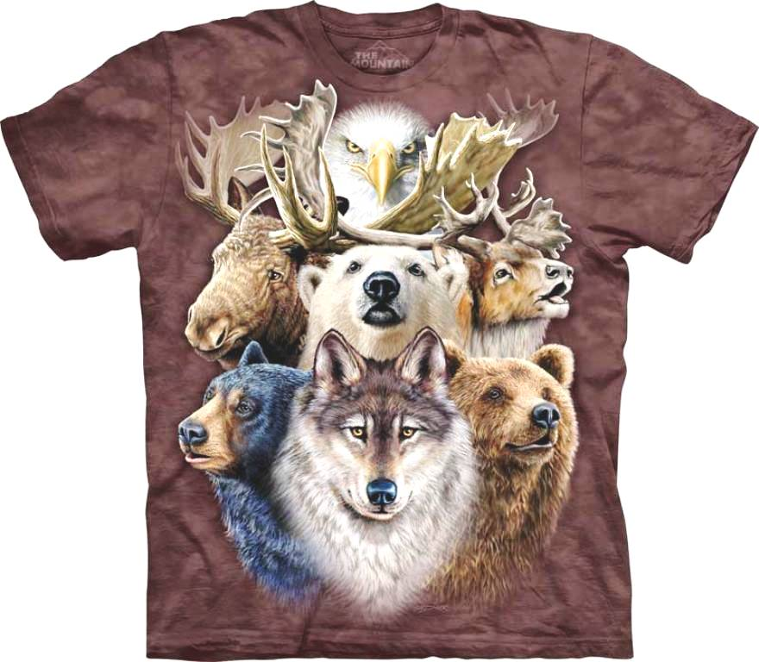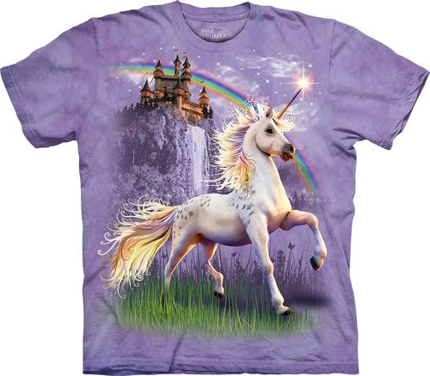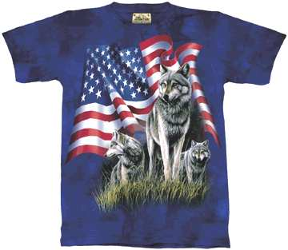

Judges: One judge is required for every 5 entries of portion thereof, in individual events and congress. One judge is required for every 3 teams of portion thereof in Public Forum and Lincoln-Douglas. One judge is needed for every 2 teams or portion thereof in CX. If you bring CX teams, bring judges who know what they are doing. CX judges must be assigned and names must be emailed to me BEFORE the tournament. Those judges will be assigned ballots and they must pick up their ballots for each round. If you don’t bring judges or if your CX judges don’t pick up their ballots, your teams will be dropped.

Fees - $15 per school, $3.50 per student per entry. Please make checks payable to Ridgeline H.S. (Debate).

Food: Drinks and pizza ($1.00/slice) will be for sale. However, we have hopes of coming up with a classier food option…TBD. However, the price will be fixed at $3.00 for a meal. Never fear, we do have a Gossner’s© milk vending machine. (Hip Hip Hooray!)

Entry Limits: Entries will be limited to 4 in each event. EXTRA ENTRIES MUST BE APPROVED OR THEY WILL NOT BE ACCEPTED!

Storytelling Rules/Guidelines: “Storytelling rules state a single published, printed story, anecdote, tale, myth or legend must be retold without notes or props. The student may not tell a story used previously in any NFL district and/or national tournament. The delivery must be extempore, not read. No book or script may be used. The contestant must not add original material or materially change the content of the story” (nflonline.org). Speeches should be 7-10 minutes long. The theme for the evening is “Adventure.”

Schedule is as follows:*

Registration: 7:30 Library

Judges Meeting 8:00 Library

Congress: 8:00-10:30 Session #1
10:31-10:59 BREAK
11:00-1:00 Session #2
1:01-1:29 BREAK
1:30-3:30 Session #3

All other events: 8:00-9:30 Round #1
10:00-11:30 Round #2
12:00-1:30 Round #3
2:00-3:30 Round #4

Awards 5 pm Auditorium

Concessions will be available from 11:30 am-1:30 pm

*Disclaimer: times are subject to change in the event of a pandemic, earthquake, Tabroom meltdown, Judges Boycott, coaches dozing off, nuclear war, or a myriad of other factors. Just go with it!

