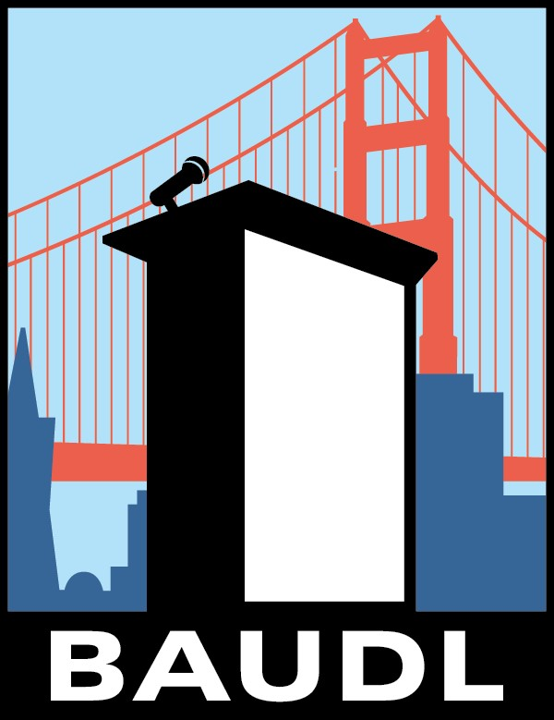

Fall Classic 2017
Middle School
Speech and Debate
Tournament
Congressional Docket and Guidelines

TABLE OF CONTENTS

How Fall Classic 2017 Congress Will Work …… pg. 2-3
Helpful Phrases And Terminology …… pg. 3-5
Fall Classic 2017 Congress Docket Order …… pg. 5
A Resolution to Make Lunch Healthy Again …… pg. 6
A Bill to Make Volunteering a Graduation Requirement …… pg. 7 A Bill to Change School Start Times …… pg. 8

HOW FALL CLASSIC 2017 CONGRESS WILL WORK:

- There will be three (3) rounds and students will debate one (1) bill/resolution per round. Students can give a second speech on a bill or resolution only if time allows, and everyone in the chamber had a chance to speak.
- The docket has been pre-set (please see the order of the legislation set below), so there will be no need to set the docket.
- Presiding Officer(s) will be nominated and elected at the beginning of each round.
- Each round may split the Presiding Officer positon amongst two students. If this occurs then the Presiding Officer will receive priority to speak.
- The Presiding Officer(s) will implement standard NFL rules and the rules outlined in this docket within the chambers. The Presiding Officer(s) will be fair and alternate between picking speakers from his/her school and other schools in the chamber.
- Speakers must stand up to be recognized to speak or ask questions. In order to vote students must stand up as well.
- Students should give speeches of 3 minutes (with 10 seconds grace period) in length either in affirmation or in negation of the bill or resolution being debated.
- Students in the chamber deliver their speeches in cycles (a cycle comprises of one affirmative speech and one negative speech) until the students decide to vote on the bill (or table it for possible later additional discussion).
- Students should wait for a cycle to complete before introducing a motion to the chamber.
- If the chamber runs out of either affirmative or negative speeches to complete a cycle Students should motion for an “open podium,” in the sense that if an affirmative speaker has just spoken, it is impermissible to give another affirmative the floor over a negation speaker, even if the affirmative speaker has precedence based on recency. The motion should be structured as follows: “I motion for open podium.” or “I move for open podium.” The motion must then be seconded and voted upon by the chamber. If it receives 2/3 majority of the votes in the chamber, then it is passed.
- After a student completes his/her 3 minute speech, the presiding officer calls on other students to ask short (generally 10 seconds or so in length) questions of the speaker who has just spoken, with only one question per each student being called upon at any one time. However, that same student may ask another question(s) once other students who have not asked questions have gone and there is still time left in the questioning period.
- The speaker answers those questions very briefly (generally roughly 10 seconds per response). The questioning period goes on for 2 minutes for the first affirmative speech and the first negative speech; and 1 minute for every speaker afterwards regardless if it is an affirmative or negative speech with as many students as possible asking questions.
- Standard questioning procedures will be used; prefacing/leading questions and two-part questions are not allowed.
- The students are permitted to motion to extend the time of the questioning period. The motion should be structured as follows: “I motion to extend the questioning period by (state by what amount of time, usually by 1 minute or 30 seconds).” The motion must then be seconded and voted upon by the chamber. If it receives a majority of the votes in the chamber then it is passed.
- Presiding officers are required to follow standard recency/precedence procedures. First priority is given to speakers who have given the fewest speeches. Between speakers who have given the same number of speeches, the speaker who has spoken the least recently is given priority. Before recency is established, ties must be broken randomly. Standing time will NOT be used during the rounds.
- Recency, precedence, and questions will reset between rounds.
- To end the session a motion to close Congress must be passed. The motion should be structured as follows: “I move for the previous question.” or “I motion to close Congress.” The motion must then be seconded and voted upon by the chamber. If it receives a majority of the votes in the chamber, then it is passed.
- Legislation may not be debated between sessions. If debate begins on a bill/resolution in one session, it must end in the same session and may not be continued to other sessions.
- In addition, the use of any electronic devices such as laptop computers, iPads, and/or cell phones or accessing the internet during Congressional debate rounds is not permitted.
- All competitors must be polite and respectful to each other in the rounds and outside of them.

The BAUDL staff will disqualify any student that does not comply with these rules.

HELPFUL PHRASES AND TERMINOLOGY:
Make a motion... “I move that (or to)...” or “I motion to...”
Leave the room (toilet, etc.)... “I motion for personal privilege. To leave the room.”
Make an amendment (see “Amendments” above)... “Move to amend.”
Close debate on the current issue... “I move for the previous question.”
Ask about an error... “Motion! Point of Order. ...”
Second a motion... “Second!”
Table... “I move to table the legislation.”

Presiding Officer/Chair - the leader of a legislative assembly who runs its meetings by recognizing members to speak or move. Also called the “presiding officer,” or “P.O.” Modeled after the Speaker of the House, or the Vice President or President pro tempore of the Senate.
Chamber - the group of students in a single room.
Cross-examination - period where the members of the assembly ask individual questions of the speaker. Multiple-part (or two-part) questions are not allowed because they take time from other members who may wish to question the speaker.
Divide the House – division of the house in parliamentary procedure refers to a vote. However, the motion to divide the house in student congress is more commonly used to determine how many speakers wish to speak on each side of a bill or resolution.
Docket - the complete packet of legislation (as titles or full text) distributed by a tournament.
Floor - when a member has the full attention of the assembly to speak (also refers to the area where the assembly meets, where its members speak, and where it conducts its business).
Legislation - a specific, written proposal (in the form of a “bill” or “resolution”) made by a member or committee for assembly to debate.
Leading Question: any question that begins with a preface (“according to the NY Times...”) or suggests the answer or contains the information the examiner is looking for (“wouldn’t you agree that this bill would...)
Motion: a formal proposal to an assembly to take a certain action.
Open Podium: refers to a situation when the order of speeches does not matter; for example, only affirmative speakers will be giving speeches.
Priority or Precedence - standard rule in most leagues (including NFL and NCFL), which requires the presiding officer to choose speakers who have spoken least (or not at all).
Recency - widely-used system (not a rule NCFL or NFL), where the presiding officer not only employs precedence, but also selects speakers based on who has spoken least recently (or earlier). Before precedence is established (applies to students who have not spoken), the following methods are often used:
Standing Time or “Longest Standing” - notes when students first seek recognition to speak; those who were standing earlier, but were not called on initially will be recognized before students who wait until later in the debate to stand.
Resolution - an expression of conviction, or value belief of an assembly, which may urge, request or suggest further action by another decision-making authority or amend the Constitution.
Bill - type of legislation that describes the details of how a policy would be enacted, if voted into law by the assembly.
Table – to put a piece of legislation aside and move on without voting on the legislation. Voting – there are three types of votes in congress:
- Voice Vote: the most efficient but least accurate. “All those in favor say ‘Ay’, opposed say ‘Nay’.
- Standing Vote: More accurate than a voice vote and the most common manner of voting in congress. Students will raise their hands or stand up.
Yield – a action in which a member is called on to speak but declines recognition thus yielding his time to another member who wishes to speak. Members who yield should lose their standing time.

FALL CLASSIC 2017 CONGRESS DOCKET ORDER:
Round 1: A Resolution to Make Lunch Healthy Again
Round 2: A Bill to Make Volunteering a Graduation Requirement
Round 3: A Bill to Change School Start Times

A Resolution to Make Lunch Healthy Again

1.  2. | WHEREAS, | Finland, Estonia, and Sweden have had enormous success providing free school meals to public school children; and
3. | WHEREAS, | The rates of childhood obesity in the US have hit 17%; and
4.  5. | WHEREAS, | Corporations have taken advantage of school cafeterias to promote their unhealthy products; and
6.  7. | WHEREAS, | School meals determine the future dietary habits of students; now, therefore, be it
8.  9. | RESOLVED, | By the Congress here assembled that public schools shall provide free healthy meals to students.

A Bill to Make Volunteering a Graduation Requirement

BE IT ENACTED BY THE CONGRESS HERE ASSEMBLED THAT:
- SECTION 1. All students enrolled in high schools across the United States shall be required
- to engage in “volunteering activities” for at least one hour a week for each
- year of enrollment.

- SECTION 2. Volunteering Activities shall include:
- A. Service learning

- B. Skills-based volunteering
- C. Environmental volunteering
- D. Community work
- E. Aiding approved religious institutions

- The student’s selected volunteering activity shall require school approval
- before the student begins the program.
- SECTION 3. This bill will be enforced by the U.S. Department of Education.
- SECTION 4. This legislation will take effect on September 1, 2018.

- SECTION 5. All laws in conflict with this legislation are hereby declared null and void.

A Bill to Change School Start Times

BE IT ENACTED BY THE CONGRESS HERE ASSEMBLED THAT:
1.  2.  3. | SECTION 1. | All public elementary, middle and high schools across the United States shall start the school day at 9:30AM and shall end at the same time as they usually do.
4.  5.  6. | SECTION 2. | In order to make time for the later start of the school day, each class will be shortened by the same amount of time. This will be calculated by each school individually.
7. | SECTION 3. | This bill will be enforced by the U.S. Department of Education.
8. | SECTION 4. | This legislation will take effect on January 1, 2018.
9. | SECTION 5. | All laws in conflict with this legislation are hereby declared null and void.

