The Vanderbilt University Invitational Intercollegiate Debate Tournament

October 13–15, 2017

Tournament Schedule

Report time/stop coaching time is 10 minutes prior to the scheduled start time.
Oral critiques should be concluded no later than 15 minutes after the announced decision time.

Friday, October 13, 2017
12:30-2pm Online check-in through Tabroom.
2:30pm Rounds 1 and 2 Pairings Released
3:30pm Round 1 start time
6:00pm Decision time for Round 1
6:00pm Dinner
7:00pm Round 2
9:30pm Decision time for Round 2

Saturday, October 14, 2017
7:00am Rounds 3 and 4 Pairings Released
8:00am Round 3
10:30am Decision time for Round 3
11:00am Round 4
1:30pm Decision time for Round 4
1:30pm Lunch
2:00pm Pairings released for Round 5
2:30pm Round 5
5:00pm Decision time for Round 5
5:30pm Pairings released for Round 6
6:00pm Round 6
8:30pm Decision time for Round 6

Sunday, October 15, 2017
7:00am Pairings released for First elim round
8:00am First elim round
11:00am (approx.) Awards ceremony
Remaining elimination rounds as needed.

Campus Map
http://www.vanderbilt.edu/map/

Parking
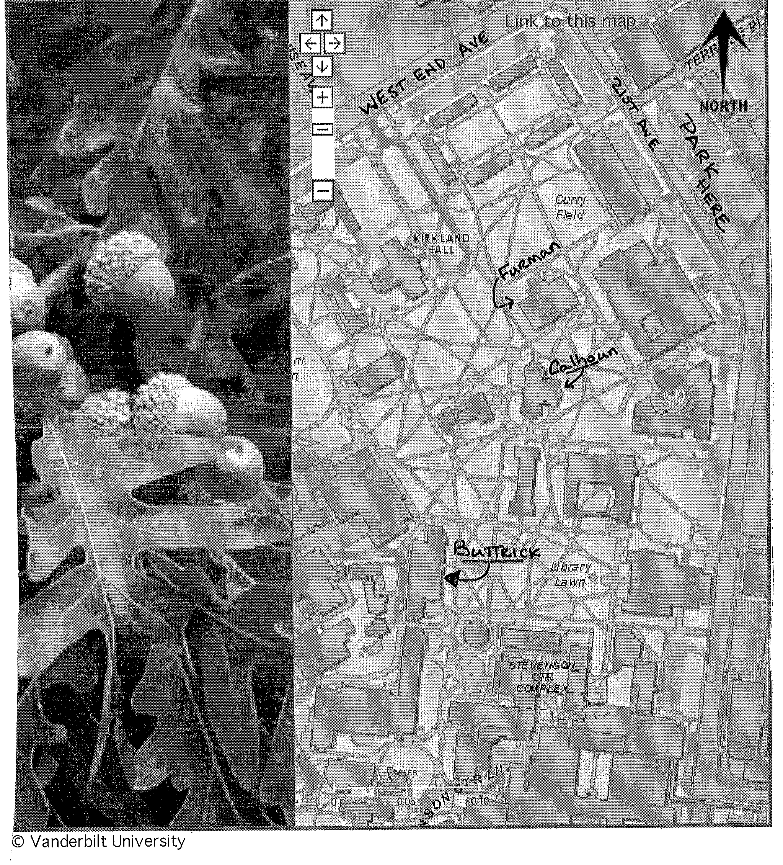

Wireless
Guests can easily setup their wireless devices to access the Internet by connecting to the wireless network (SSID) named "vummiv.”
Connecting to vummiv on Windows Machines
- Right click on the Wireless icon located in the bottom right hand corner of the taskbar
- Click, “Open Network and Sharing Center”
- Click, “Setup a new connection or network”
- Click, “Manually connect to a wireless network”
- Click "Next"
- On the Manually connect to a wireless network page enter the following information
  - Network Name: "vummiv"
  - Security Type "No authentication (Open)"
  - Encryption Type leave as "None"
  - Check the box next to “Start this connection automatically”
  - Check the box next to “Connect even if the network is not broadcasting”
- Click "Next"
- Close the connection wizard, if you are in range of the vummiv signal your system will connect

General Information
    - There will be a ballot/information table in the Buttrick atrium.
    - Vanderbilt does not allow smoking in any building. Designated smoking areas map on next page.
    - Time limits are 9-3-6 with 10 minutes prep time.
    - Report time/stop coaching time is 10 minutes prior to the scheduled start time.
    - Oral critiques should be concluded no later than 15 minutes after the announced decision time.
    - We will use the 2017-2018 CEDA/NDT/ADA resolution.
    - Awards will be presented to teams qualifying for elimination rounds.
    - The top speakers in each division will receive Speaker Awards.
    - Forfeit Rule: There is a 15-minute forfeit rule in effect beginning with Round 1.
    - Judges should contact the ballot table before declaring a forfeit.
    - Evidence (if you still use tubs) may be stored each night in Buttrick.
    - A gender-neutral restroom is available on the Fourth Floor of Buttrick.
    - CEDA STATEMENT ON SEXUAL DISCRIMINATION: This tournament abides by the CEDA statement on sexual discrimination and encourages an inclusive atmosphere for all those participating. Insofar as possible, the procedures in the CEDA statement will be followed for complaints based on race, gender, and sexual orientation.
    - Phone numbers: M. L. Sandoz 615-500-6184 (cell) Neil Butt 540-290-5827 (cell) John Koch 330-280-3310 (cell)

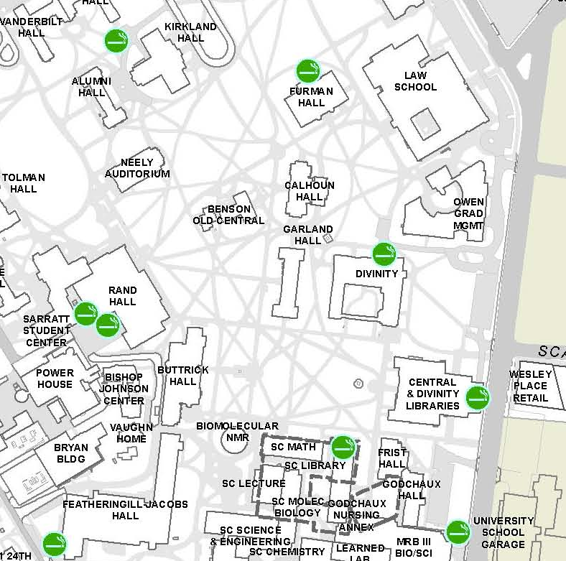

Judging Information

• Judges should assign speaker points (1-30 with tenths of points and NO ties) to each individual speaker and choose a winning team.
• Please clearly indicate a low point win on the ballot.
• Report time/stop coaching time is 10 minutes prior to the scheduled start time.
• Oral critiques should be concluded no later than 15 minutes after the announced decision time.
• Oral critiques are great, but please submit your ballot on-line before giving an oral critique.
• Judges are asked to provide some feedback on the ballot to confirm their decisions.
• Judges should contact the ballot table before declaring a forfeit.
• All judges have a commitment of one round past their squad’s elimination.
• Time limits are 9-3-6 with 10 minutes prep time.
• We will use the 2017-2018 CEDA/NDT/ADA resolution.
• CEDA STATEMENT ON SEXUAL DISCRIMINATION: This tournament abides by the CEDA statement on sexual discrimination and encourages an inclusive atmosphere for all those participating. Insofar as possible, the procedures in the CEDA statement will be followed for complaints based on race, gender, and sexual orientation.
Phone numbers: M. L. Sandoz 615-500-6184 (cell)
Neil Butt 540-290-5827 (cell)
John Koch 330-280-3310 (cell)

A Quick List of Places to Eat Around Vanderbilt

Bruegger’s Bagel: 422 21st Ave South—walking distance. A variety of bagel sandwiches, including great vegetarian humus. Fairly cheap and really good.
Panera Bread: 406 21st Ave South—walking distance. Great sandwiches, soups, salads, and bakery items. Fast and good.
San Antonio Taco Company (SATCO): 416 21st Ave South — walking distance. Cheap but still good Mexican food. You can even sit on the porch under electric heaters and listen to classic rock while drinking buckets of beer.
Chipotle: 400 21st Ave South — walking distance.
Subway: next to Chipotle.
Mellow Mushroom: 212 21st Ave South — walking distance. Great pizza and subs, calzones, and salads. Yum!!
Qdoba: at the corner of 21st and West End. Mexican fast food but not as fast, or greasy, as Taco Bell and thus not as cheap.
Sitar: 116 21st Ave North—walking distance. Great Indian food and good price. Wonderful lunch buffet.
Jason’s Deli: 2028 West End—walking distance. Salads, sandwiches, soups, big salad bar.
5 Guys Burgers: 2018 West End—walking distance.
Jersey Mike’s Subs and Salads: 2311 Elliston Place—walking distance. Excellent subs. Lots of choices.
Calypso Café: Elliston Place Plaza— very short drive or slightly longer walk. Excellent Jamaican style food including rotisserie chicken and great salads. Good veggie options. It is really quick and very cheap, sit down or take out.
Logan’s Roadhouse: 2404 Elliston Place— walking distance. Country music, peanuts on the floor, and really good buttery sweet rolls.
Jimmy John’s: 2318 West End Ave— walking distance. Cheap but good sub shop.
Café Coco: 210 Louise Ave (off Elliston Place)— very short drive or slightly long walk. Great food open 24 hours - who could ask for anything more? Oh yeah – coffee AND beer in one place, often with live music on the back porch!
Chili’s: 2322 West End Avenue — walking distance.
Broadway Brewhouse & Mojo Grill: 1900 Broadway—between campus & hotel. Cajun / Southwest. It’s a dive, but it’s quite good food. The restaurant is up front, bar in back (but you can eat anywhere) 69 beers on tap and lots of other stuff in bottles.

Fast Food within walking distance: Subway (see above); Checker’s—2000 West End Ave; Taco Bell—2004 West End Ave; Jack in the Box—2006 West End Ave; Cook Out West End Ave.

There’s plenty more restaurants near campus and lots downtown, especially on exciting 2nd Ave. Or you can head to Germantown for Monell’s – great authentic Southern cooking. Talk to a Vandy student or the hotel concierge for more information.

