Welcome to the Gotham Debates at the New School!
We are thrilled to have you. Please bear with us as we navigate some of the challenges of hosting on an urban campus (in the northeast in winter ….).
We will offer 6 Preliminary Rounds of Debate. We are initially offering 3 Divisions: Nov, JV, Open. If entry numbers and tournament logistics dictate, we will make a decision to collapse JV and Open sometimes on Feb 7th.
Please Register by Wed, Feb 7th to allow for catering needs. If you are intending to come but waiting to register please also let us know to ensure we have all of the facilities we need.
TOPIC: We will use the 2017-2018 CEDA “national health insurance” resolution.
DISCRIMINATION & HARASSMENT: The New School abides by the CEDA polices on Discrimination & Sexual Harassment.
LOCATION:
The central tournament location will be the Vera Lang Center on 6 East 16th Street, on the south side of the block between 5th Avenue and Union Square Park. For navigation purposes, you can always ask someone for directions to “Union Square” if you have significant direction issues in Manhattan. Union Square is also the nearest subway stop for the N,R,Q,4,5,6,L trains if you have judges coming from home in the City.
We may use other buildings on the “campus” during rounds 2,3,4. These buildings will be 2 or 3 “short” blocks away (2 short blocks = 1/10th of a mile). It will be a grid system if you need to find these buildings.
Facility Notes:
The 6 East 16th Street Building alternates floors for gendered bathrooms on the upper floor, and has an all gender bathroom on each of these floor (eg: a floor will have an all gender restroom and EITHER a Men’s or Women’s room. The next floor will have an all gender restroom and the other gender bathroom).
If you have mobility limitations please email vikeenan@gmail.com with the subject “ADA Tabroom Note” to ensure that we have the appropriate accommodation if needed.
Hotel:
We recognize that Hotels in NYC are expensive, and so we have options based on your priorities as a squad. We also recognize that some teams have preferred vendors. In general, we encourage you to make the arrangements that best suit your team rather than requiring you to centralize at one tournament hotel. That said, the number of hotels in NYC can be completely overwhelming. The following blocks are located to help you narrow search options even if you do not want to use the block. The NJ Holiday Inn is in a central location with a few other hotel chains nearby. It is about a 15 minute drive into the city around 7AM on a weekend via the Lincoln Tunnel (there is a toll). The Manhattan options are about .5 miles from the primary tournament building (on a nice day you could walk).
We have the following block in Manhattan:
Holiday Inn Manhattan 6th Ave - Chelsea
125 W. 26th Street New York, NY 10001
Main: 212-430-8500
www.hi-nyc.com
(10 blocks from tournament) – Rate $129/night for Double Doubles (plus tax).
Please reserve by Monday, Jan 29th. 24 Hour Cancellation Policy.

Sales Contact if you have issues: John R. Solema, Direct: 718.513.5105 Fax: 212.430.8501

We’ve reconfigured the block to allow you to connect with the hotel directly and not deal with IHG.
Online Link:
New School Debate Group Code: NSD
https://www.holidayinn.com/hotels/us/en/new-york/nycvc/hoteldetail?qAdlt=1&qBrs=6c.hi.ex.rs.ic.cp.in.sb.cw.cv.ul.vn.ki.sp.nd.ct&qChld=0&qFRA=1&qGRM=0&qGrpCd=NSD&qIta=99801505&qPSt=0&qRRSrt=rt&qRef=df&qRms=1&qRpn=1&qRpp=20&qSHp=1&qSmP=3&qSrt=sBR&qWch=0&srb_u=1&icdv=99801505

Or call in and say you are booking with the New School Debate (NSD) block. (212-430-8500)

Sales Contact if you have issues: John R. Solema, John.Solema@hi-nyc.com, , Direct: 718.513.5105 Fax: 212.430.8501

There is a larger block for Friday and Saturday night and a few rooms with the same block rate on Thursday or Monday as your travel needs dictate. If you cannot book by Jan 29th there is an additional code we can provide to still have a discounted rate at this location after the 29th.

We have the following recommendation in New Jersey:
Holiday Inn Express North Bergen - Lincoln Tunnel
2600 Tonnelle Avenue
North Bergen, New Jersey 07047

Rates Average about $95-$105/night for double doubles depending on if you have a university vendor contract. If you are traveling with a BUS we recommend this location.

This in in Jersey. Pros: Cheaper, free parking at hotel; Cons: Further, need to pay toll to Manhattan and parking in Manhattan, not a scenic part of Jersey

If you use this address, there is a Best Western and Super 8 across the street, and a Howard Johnson and Quality Inn just south on the same road of these are preferred vendors.
In the spirit of environmentalism and travel safety, we would like to encourage programs that are able to consider the possibility of mass transit options such as train or bus if cost comparable. This would eliminate your need to drive and park in Manhattan and might make the walkable hotel options more user friendly for you. If you are flying in, for the love of all that good and holy, do not rent a car for this tournament. If you have questions about options just let me know.
PARKING:
The elephant in the room. Yup, NYC is not the easiest or cheapest place to park.
Simplify your life and select one of the 3 lots (within 2 blocks of the New School Buildings) below and make and prepay a reservation before you arrive
How to Prepay:
https://www.parkwhiz.com/
Enter the address for “6 East 16th Street, New York, NY”
Set the time of entry at 6:30 AM and departure as 11PM (it will be the same rates for anything before midnight) for Saturday, Feb 10th
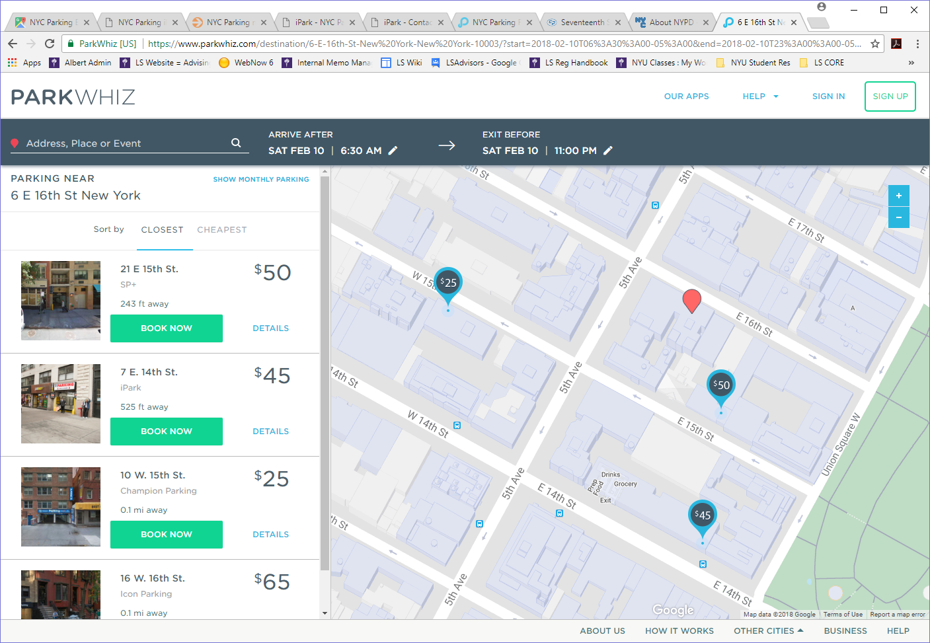
Select from the appropriate option:
Regular car or minivan or SUV:
10 West 25th (Champion) - $25/day for car or $35/day for minivan or SUV (double check height restrictions)
15 Passenger Vans:
41 West 17th - $50-65/day (this is an open lot to avoid height clearance issues)
Repeat for SUNDAY.
If you are driving into the city in a car or minivan and parking for Fri-Sunday also contact the hotel for options.
Additional Suggestion: 7 East 14th iPark – a $45-65 Rate, $120 for whole weekend Friday PM-Sunday PM. Higher clearance than 15th street above. Availabel on Park Whiz (recommended for large or long term)
This location often has COUPON deals, for example 12 Hours for $30 on a weekend or with early entry, or $40 for 24 Hours. http://ipark.com/garage/east-14th-garage-corp. The next Coupon Offer will be posted after January 22nd, at which time they may also send me special coupon rates for our event. Clearance is low however.
Registration Fee Reductions for Parking Costs:
If you select the options to prepay online in advance, send or bring me a copy of each reservation. Based on your reservations, you will receive a Tournament Registration Fee reduction along the following scale:
- 11-15 Passenger Van parked: waive fees for 2 individuals in your groups up to 10 or 3 individuals for a vehicle transporting 11-15.
- Minivan or SUV at 15th Street: waive fees for 2 individuals
- Car at 15th Street or parking at 14th Street waive fee for one individual
- *Hotel parking: Please speak to Vik for Fee Waiver schedule and parking suggestions

Fees: $45/person
Fee reduction for parking expenses based on schedule above under Parking.
Uncovered Commitment: $150/Team – you can either hire directly from the judge exchange (preferable if you have cash options for payment, we can give you receipts) or ask the tournament to hire and pay us the fees.
Make checks out to “The New School”. Please note “New School Debate” in Memo.
We are trying to activate a credit card option by Jan 30th.
Directions: Look, we have GPS now. But the short answer is that 5th Avenue travels from North to South. All of the Hotels and the Lincoln Tunnel are NORTH of the New School “Campus”. Eventually, you head South in the direction of traffic on 5th Ave (or 7th ) and turn LEFT on 16th street. The building in on the RIGHT.
16th Street will then dead end into Union Square. For parking, turn Right on Union Square East. Waive at the NYU dorm on your right. For the 15th Street Parking Option, turn Right again on 15th Street, go one block and cross 5th Avenue, and the parking lot is the next block. For the 14th Street Garage, go down to 14th Street and turn right and the garage is on your right. For the 17th Street Lot, turn right on 15th, go two blocks to 6th Ave, turn right on 6th, Right again on 18th, right again on 5th Ave, and right again on 17th (or stop here first before walking one block to tournament).
Navigation: Even streets run from West to East (so you cross 7th, then 6th, then 5th Ave). Odd Streets run East to West (So 5th Ave to 6th Ave to 7th Ave). Avenues run North/South, with odd Avenues heading South and Even Avenues running North. 14th, 23rd, 34th, and 42nd are 2 way streets. Broadway runs diagonally North to South (cross 7th at 42nd, 6th at 34th, 5th at 23rd, and into Union Square). Around Broadway there are limited left turns and sometimes designated pedestrian access.

Schedule:
Saturday, Feb 10th
7AM – Electronic posting of Rounds 1 and 2
7:15AM - Registration and Breakfast in 6th East 16th Street (Building will not open until 7AM)
8AM – Round 1
10:30AM – Round 2
1PM – Lunch
2PM – Round 3
4:30PM – Round 4 (depending on tournament logistics, may be lag paired off 2)
6:30PM – Dinner
7:30PM – Round 5

Sunday, Feb 11th
7AM – Electronic posting of Round 6
7:15AM - Registration and Breakfast in 6th East 16th Street (Building will not open until 7AM)
8AM – Round 6
11AM – 1st Elim
1:30PM – Lunch & Awards
2:30PM – 2nd Elim
5:30PM – 3rd Elim
7:30PM – Finals if required

FOOD: Breakfast will be tournament typical carb heaviness, but they ARE authentic NYC bagels. Saturday meals will include Mediterranean (likely) and Indian. Sunday Lunch will be NYC style Pizza, including Gluten Free and Vegan options.
CONTACT:
Vik Keenan
vikeenan@gmail.com, 347-683-6894

