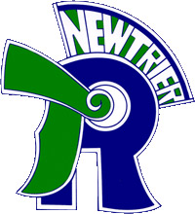
Trevian Invitational
New Trier Township High School
Winnetka, IL
Tournament Enrollment Form

The following students are currently registered to compete at the Trevian Invitational policy debate tournament hosted by New Trier Township High School in Winnetka, IL.
By signing below, I verify that the student names are correct and that each student is enrolled and in good standing with our academic school institution.

__________________________________________________________________________ _______________________________
Signature of school administrator/principal Date

