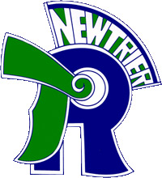
Trevian Invitational
New Trier Township High School
Winnetka, IL
Non-School Chaperone Form

Administrative Signature Required
The signatory below acknowledges that an individual other than a school employee shall be serving as the primary chaperone for their institution’s debate program at the Trevian Invitational policy debate tournament, hosted by New Trier Township High School. The individual listed below shall be the point of contact for all tournament related activities, including but not limited to locating/supervising students, judges, and fulfillment of obligations at the tournament.
They shall also be the point of contact in the event of any emergencies involving the school’s students. This individual shall be responsible for handling any and all communication with the student(s), parents, medical professionals, and medical institutions.
Non-School Chaperone Signature Required
The individual serving as the chaperone acknowledges their responsibilities as outlined above and agrees to fulfill those duties on behalf of their respective school.

Name of the non-school chaperone:

_____________________________________________________ _________________________
School Administrator signature Date

_____________________________________________________ _________________________
Non-school chaperone signature Date

