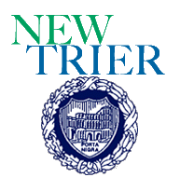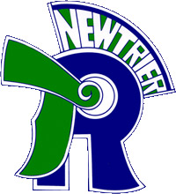
Trevian Invitational
Policy Debate Tournament
New Trier Township High School
Winnetka Campus
385 Winnetka Ave. – Winnetka, IL 60093

Dear colleagues,

New Trier Township invites you and your policy debate teams to attend the 2017 “Trevian Invitational” (formerly the New Trier Season Opener). The tournament will run Saturday, October 7th through Monday, October 9th. Beyond changing the tournament name, we are also moving the tournament to our newly renovated Winnetka campus! Debates on Saturday and Sunday will take place at the New Trier Winnetka Campus (385 Winnetka Ave. Winnetka, IL 60093). Late elimination rounds (quarters through finals) will take place at the Renaissance North Shore (933 Skokie Blvd, Northbrook, IL 60062).

Our goal is to run an efficient tournament that balances a highly competitive field with a healthy and balanced life style for students and coaches. The schedule is designed to provide coaching time in between rounds and allow teams to return to their hotels at a reasonable hour. Due to cost increases, our registration fee will be $140 per team. This includes light breakfast options as well as lunch on Saturday and Sunday. We will also serve breakfast for competitors, coaches, and judges participating in Monday’s elimination rounds. Concessions will be available throughout the tournament. All competitors and coaches will also be given a Trevian Invitational t-shirt.

We will maintain some of the registration requirements and rules enacted last year. In order to ensure that the Trevian Invitational is in line with some accepted best practices, we are asking schools to complete:
- Tournament/student enrollment form
- Non-school chaperone form (if applicable)
- Audio permission form

Additionally, we ask that you review our judge policy for the tournament. Due to previous concerns, we have had to adjust and clarify our judging expectations.

Thank you for your consistent support of our tournament! Our administration, staff, and students look forward to welcoming you to our brand new facilities while maintaining the same quality and hospitality that you’ve come to expect from our tournament!

Sincerely,

Aaron Vinson & David Weston

