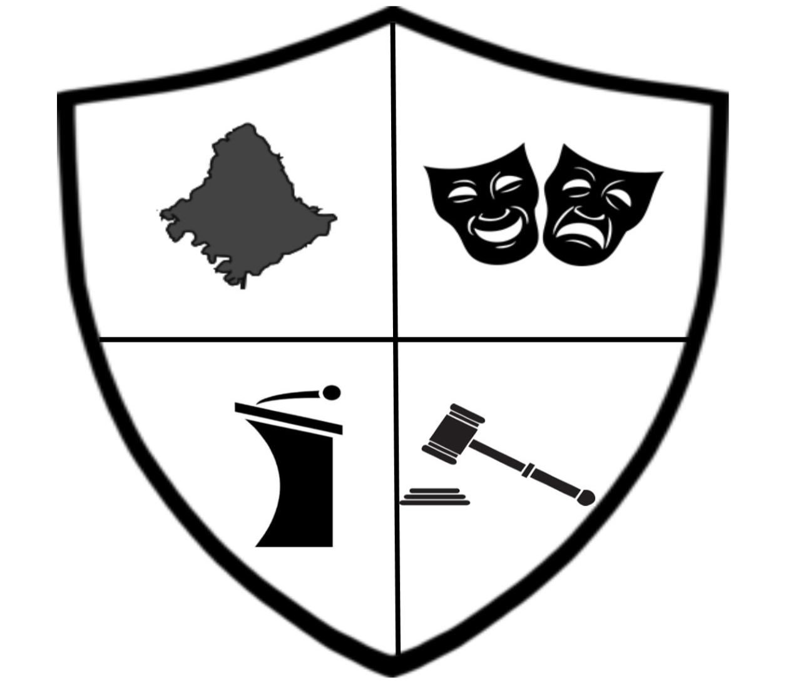

Dear Elementary, Middle, and Junior High School Speech Coaches,
The Rowan County Senior High School Speech and Debate Team and Boosters are pleased to invite you to the Harlen Hamm Tournament for Middle Schools on Saturday, January 27, 2018, in Hindman, KY! We will be hosting at Knott County Central High, and we are so grateful to them for offering to allow us to use their facilities!

DEADLINES
- Entries and fees will freeze on Wednesday, January 24, at 3:30pm. After this time, $5 will be charged for each add/drop on top of the entry fee.
- Drop/make substitutions yourself online until 3:30pm on Friday, January 26. After this time, you must contact Ryan Brown to make any changes.

EVENTS AND ENTRIES
Teams may have unlimited entries in each event. Single entry events will cost $5 each; partnered entry events will cost $10 each. Students may compete in up to two events per flight.
- Flight A events: Broadcast, Duo Acting, Extemp, Oratory, Prose, Solo Acting
- Flight B events: Declamation, HI/DI, Impromptu, Improv Duo, Poetry, Storytelling

JUDGES
Teams must bring one judge for every six speech entries or fraction thereof. Each missing speech judge will cost $35. Please make sure all judges are trained and familiar with KHSSL rules and policies. Juniors and seniors on the RCSHS and KCCHS teams will serve as judges.

SCHEDULE
8:30-9:30 – Registration
9:30-10:00 – Extemp Draw/Judge meeting
10:00-11:30 – Flight A, Round 1 (Bro, Duo, Ext, OO, Pro, Solo)
11:30-12:00 – Extemp Draw
12:00-1:30 – Flight A, Round 2
1:30-3:00 – Flight B, Round 1 (Dec, HI/DI, Imp, Impv, Poe, Sto)
3:00-4:30 – Flight B, Round 2
4:30-5:00 – Extemp/Broad Draw
5:00-6:30 – Finals
7:00 – Awards

AWARDS
The top six in each event, as well as the top six in individual sweepstakes, will receive medals. The top three teams in sweepstakes points will receive trophies.

FOOD
A hospitality room will be provided for all adults. Competitors will have a concession area in the cafeteria. Please make sure students know to bring small bills for concessions. Proceeds from concession go to the KCCHS team!

Thank you for adding the Harlen Hamm Tournament for Middle Schools to your competition schedule! We can’t wait to see you in Hindman on January 27!

Ryan Brown, RCSHS Head Coach
ryan.brown@rowan.kyschools.us | 606-776-5089

