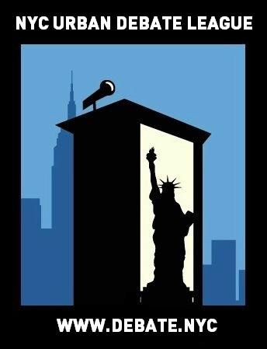
NYCUDL Queens High School Scrimmage
The Young Women’s Leadership School of Queens

On behalf of the New York City Urban Debate League and The Young Women’s Leadership School of Queens, you are cordially invited to the NYCUDL Queens High School Scrimmage on June 9th, 2017 for a afternoon of exciting, fun and intense debate. We will offer one debate format, Public Forum Debate, featuring two rounds of debate for that format.

Judges’ training will be available for individuals interested in judging Public Forum Debate.

All questions, concerns and/or issues about the tournament should be directed to:

Program Manager: Courtney Kaufman – 917-774-6539 or courtney@debate.nyc

Looking forward to seeing you all,

Courtney Kaufman – Program Manager, New York City Urban Debate League

Registration

Registration will take place on Tabroom. We are listed as the NYC Urban Debate League circuit. If you do not have an account with Tabroom, you can easily set up through tabroom.com

Judges
Each school requires one judge for every two teams competing.

REGISTRATION DEADLINE FOR ALL ENTRIES IS 5PM on June 7th, 2017

Topics

Public Forum:

Public Forum Debate: May NSDA Topic:

- Resolved: The United States ought to replace the Electoral College with a direct national popular vote.

IMPORTANT DATES

To submit teams into Tabroom: Wednesday, June 8th by 5PM

Check-in / Day of tournament registration: Friday, June 9th, by 4:00PM (latest)

Once registration closes (at the beginning of the tournament) – those that are late will forfeit the first round and will debate round two – they can still observe and flow debates in round one.

WE MUST EMPHASIZE THIS RULE IN ORDER TO HAVE AN EFFICIENT, TIMELY AND WELL-MANAGED TOURNAMENT. PLEASE OBLIGE TO THIS REQUEST.

TRAVEL DIRECTIONS TO THE TOURNAMENT

Location: The Young Women’s Leadership School of Queens
Address:

Trains: E, F, J, Z

Buses: Q1, Q110, Q111, Q112, Q113, Q114, Q17, Q2, Q20A, Q20B, Q24, Q25, Q3, Q30, Q31, Q34, Q36, Q4, Q40, Q41, Q42, Q43, Q44-SBS, Q5, Q54, Q56, Q6, Q65, Q76, Q77, Q8, Q83, Q84, Q85, Q9, X68

TOURNAMENT SCHEDULE

FRIDAY – June 9th, 2017

4:00 PM - Students arrive
4:15 PM - Round 1
5:15 PM - Round 2
6:15 PM - Pizza and awards
6:45 PM - Dismissal

