Announcing the Gettysburg Address Debates

President Lincoln spoke words so powerful and so inspirational that his message still reverberates around the globe more than 150 years later. In honor of Lincoln’s ‘Gettysburg Address’ and the man for whom we name the Lincoln-Douglas Debate event, we are offering you the opportunity to use your own powers of rhetoric as you debate other worthy opponents. We encourage you to continue your weekend with all things Lincoln. You can visit the site of one of Lincoln’s most famous speeches at the Soldier’s National Cemetery.

Contacts: ldandignac@gettysburg.k12.pa.us kodowd@gettysburg.k12.pa.us
l

Where: Gettysburg Area High School
When: Friday, December 15, 2017 (do not arrive until after 2:50 or you may encounter some large yellow vehicles.)
Time: 4:00 to 9:00 PM
Debate Events: Public Forum & Lincoln- Douglas
Topics: LD: Resolved: Wealthy nations have an obligation to provide development assistance to other nations.
PF: Resolved: NCAA student athletes ought to be recognized as employees under the Fair Labor Standards Act.

Fees: $8 per LD competitor / $16 per PF team $15 school fee (fee waived for two students or less)
Judges: 1 Judge per 2 individuals or PF team. There are limited judges for hire at $20 each.
Dinner: Available for purchase at $8. Menu: Pasta/vegetable dish, salad, and apple crisp (same as last year). Meals for judges/coaches are provided.
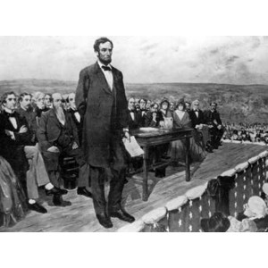
Awards: Plaques will be awarded to 1st through 5th place winners.

Miscellaneous but Important Information:
Registration begins at 3:15. Please call ahead if you have any drops. My number is 717-586-6587.
Opening begins at 3:45.
Debate rounds will run at 4, 5:15, 7 and 8:15.
Dinner will be served between rounds 2 and 3.
We will use power matching for rounds 3 and 4.
Our school address is 1130 Old Harrisburg Rd, Gettysburg, PA 17325.
After 2:50, you may park in the bus lane.
Enter through the front doors by the flagpole. Registration desk will be in front and students may find a table in the cafeteria.
Tab room will be in the library, first floor.
Tab room number is 717-586-6587. Texting is fine.
Student volunteers wearing a blue 4N6 shirt can answer your questions or direct you.
When not competing, students should not remain in any of the classrooms.

