UC Davis Aggie Invitational
May 6 2017 | Topic: Bioethics

Welcome
Welcome to the first annual UC Davis Parliamentary Debate invitational! By participating in this tournament you are helping the UCD Debate team fund another year of competition. Annually, UC Davis hosts the leading academic professionals of bioethics in the country; thus, the focus of this tournament will select from bioethical discussions. The first three rounds will be preliminary and the last round will be power-matched.

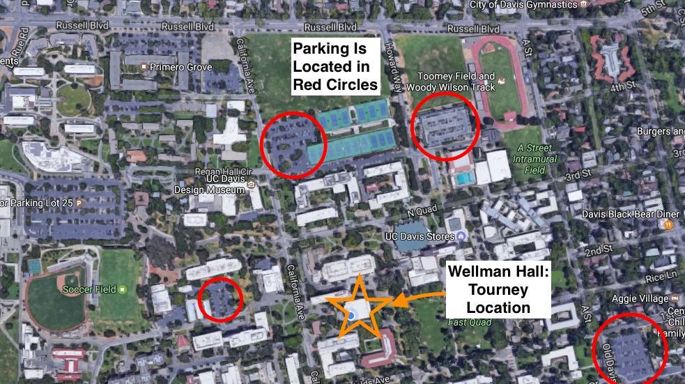
Location:
The tournament will be held at Wellman Hall at UC Davis. Parking can be found at the Memorial Union Parking Lot (UC Davis Parking Lot 16, One Shields Ave, Davis, CA 95616) and is free on weekends.

When you Arrive:
Please check in at Wellman Hall room 106 between 8:00am-8:30 am. Wellman Hall is located southwest of the Memorial Union on the UC Davis campus. Parking is free on weekends, and is designated on the map above.
Please bring payment and signed waiver to registration (waiver forms can be found at the end of this document). **NOTE: YOU MUST BRING THE SIGNED WAIVER IN ORDER TO REGISTER**
Judging instructions will be provided at 8:30 am and the first round will kick off at 9:00 am. A copy of the round schedule can be found on: http://ucdavis.tabroom.com.
Note to competitors: Internet prep will be allowed. Sign on to the guest network wifi by selecting “ucd-guest” and create an account.

Food
A selection of Subway sandwiches will provided for the judges/coaches. Memorial Union will have food options for students by purchase only. Students and Parents may also go to downtown for more options.

Before you Come:
Please bring signed waivers. Campus policy does not allow non-UC Davis students under the age of 18 to participate without these forms being signed. Thank you for your cooperation.
Agenda*:
Registration: 8:00-8:30 am
Round 1: 9:00-11:00 am
Round 2: 11:30 am - 1:30 pm
Round 3: 2:00 - 4:00 pm
Round 4: 4:30 - 6:30 pm
Awards: 7:00 pm.

Participant’s name (please print):____________________________________
UNIVERSITY OF CALIFORNIA, DAVIS
Name of Registered Student Organization (RSO): Debate at Davis
UC Davis Invitational
Waiver of Liability, Assumption of Risk, and Indemnity Agreement

Waiver: In consideration of being permitted to participate in any way in
Parliamentary debate at UC Davis
Hereinafter called “The Activity,” I, for myself, my heirs, personal representatives or assigns, do hereby release, waive, discharge, and covenant not to sue The Regents of the University of California, its
Officers, employees, and agents, and Debate at Davis and its officers and members from liability
from any and all claims including the negligence of The Regents of the University of California, its
officers, employees and agents, and Debate at Davis and its officers and members, resulting in personal injury, accidents or illnesses (including death), and property loss arising from, but not limited to, participation in The Activity.
Signature of Parent/Guardian of Minor____________________________ Date______________
Signature of Participant______________________Date______________
Assumption of Risks: Participation in The Activity carries with it certain inherent risks that cannot be eliminated regardless of the care taken to avoid injuries. The specific risks vary from one activity to another, but the risks range from 1) minor injuries such as scratches, bruises, and sprains, 2) major injuries such as eye injury or loss of sight, joint or back injuries, heart attacks, and concussions to 3) catastrophic injuries including paralysis and death.

I have read the previous paragraphs and I know, understand, and appreciate these and other risks that are inherent in The Activity. I hereby assert that my participation is voluntary and that I knowingly assume all such risks.

Indemnification and Hold Harmless: I also agree to INDEMNIFY AND HOLD The Regents of the University of California and Debate at Davis HARMLESS from any and all claims, actions, suits, procedures, costs, expenses, damages and liabilities, including attorney’s fees brought as a result of my involvement in The Activity and to reimburse them for any such expenses incurred.

Severability: The undersigned further expressly agrees that the foregoing waiver and assumption of risks agreement is intended to be as broad and inclusive as is permitted by the law of the State of California and that if any portion thereof is held invalid, it is agreed that the balance shall, notwithstanding, continue in full legal force and effect.

Acknowledgment of Understanding: I have read this waiver of liability, assumption of risk, and indemnity agreement, fully understand its terms, and understand that I am giving up substantial rights, including my right to sue. I acknowledge that I am signing the agreement freely and voluntarily, and intend by my signature to be a complete and unconditional release of all liability to the greatest extent allowed by law.
Signature of Parent/Guardian of Minor____________________________Date_____________
Signature of Participant______________________________ Date_____________
Participant’s Age (if minor)________________

UC Davis Invitational REGISTRATION FORM

· Please complete the Participant and Emergency Information on page 1 and Waiver on page 2.
· Participation will not be allowed without signed and completed form.

Participant Information
First name______________________Middle Initial_____ Last Name_____________________
Birthdate_________________ Grade_______________ Gender__________ Address_________________________________ City_______________________________________________ State____________________ Zip Code_____________________

Household Information Parent/Guardian #1:_____________________________
Parent/Guardian #2:_____________________________
Day Phone:__________________________
Additional Phone(s) (cell, pager, other)_________________________
Additional Phone(s) (cell, pager, other)_________________________
Email Address (Parent/Guardian 1):______________________________
Email Address (Parent/Guardian 2):______________________________

Medical Information
Please list all of the following to provide staff with your youth’s medical needs. This information will be kept confidential.
Allergies (including food and medication allergies), whether youth carries epinephrine pen, dietary restrictions, all medications to be taken with dose and schedule, and any other medical issues (e.g. respiratory, diabetes, cardiac, neurological) and attach additional information as needed:
Emergency Contacts: In the event a parent/guardian cannot be reached, please list two additional contacts.
Name:__________________________ Name:__________________________
Relationship:________________________
Relationship:________________________ Phone:__________________________
Phone:__________________________

Parent/Guardian Printed Name___________________________
Signature________________________________ Date_______________________

