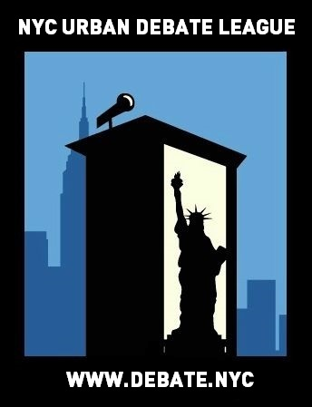
NYCUDL High School Tournament #2
Midwood High School

On behalf of the New York City Urban Debate League and the Institute of Collaborative Education, you are cordially invited to the NYCUDL High School Tournament #2 on November 12, 2016 for a day of exciting, fun and intense debate. We will offer two debate formats, Public Forum and Policy Debate, featuring three rounds of for both formats.

Judges’ training will be available for individuals interested in judging Public Forum and Policy Debate.

All questions, concerns and/or issues about the tournament should be directed to:

Program Director: Aubrey Semple – 347-440-5809 or aubrey@debate.nyc

Looking forward to seeing you all,

Aubrey Semple – Program Director, New York City Urban Debate League
Erik Fogel – Executive Director, New York City Urban Debate League

Registration

Registration will take place on Tabroom. We are listed as the NYC Urban Debate League circuit. If you do not have an account with Tabroom, you can easily set up through tabroom.com

Permission Slips: One permission slip per year is legally required for each student. This permission
slip protect and promote our debaters – they enable us to track attendance and record accurate debate time which is necessary for National Speech & Debate Association points and qualification for competitive tournaments. We are requesting that coaches turn in all permission slips by the Wednesday before each student’s first Saturday tournament. For this tournament, please turn in permission slips by Wednesday November 9, 2016.

You can access the permission slip here: https://www.tfaforms.com/345757

The NYCUDL will not accept any permission slips on the day of the tournament. Without a permission slip, a student cannot debate.

Each school requires one judge for every two teams competing.

REGISTRATION DEADLINE FOR ALL ENTRIES IS 5PM on November 9TH, 2016

Points will be on the scale of 30 points, within the range of 25-30 points.

We will provide awards for top speakers, top teams and sweepstakes points for top schools.

Topics

Public Forum:

National November PF Topic: Topic: Technology – Resolved: On balance, the benefits of the Internet of Things outweigh the harms of decreased personal privacy.

Policy Debate:

National NSDA Topic: China Resolved: The United States federal government should substantially increase it economic and/or diplomatic engagement with the People’s Republic of China.

IMPORTANT DATES

To submit teams into Tabroom: Wednesday, November 9th by 5PM

Check-in / Day of tournament registration: Saturday, November 12th, by 9:00AM (latest)

Once registration closes (at the beginning of the tournament) – those that are late will forfeit the first round and will debate round two – they can still observe and flow debates in round one

WE MUST EMPHASIZE THIS RULE IN ORDER TO HAVE AN EFFICIENT, TIMELY AND WELL-MANAGED TOURNAMENT. PLEASE OBLIGE TO THIS REQUEST.

TRAVEL DIRECTIONS TO THE TOURNAMENT

Location: Midwood High School
Address: 2839 Bedford Avenue Brooklyn, NY 11210
Buses:
B103, B11, B41, B44 ,B44-SBs, B49, B6, B8, BM1, BM2, BM3, BM4, Q35

Trains:
2 & 5 Trains – Flatbush Avenue – Brooklyn College

TOURNAMENT SCHEDULE

SATURDAY –November 12th, 2016

8:00 AM - Breakfast and Registration
9:00 AM - Registration ends

Policy Debate

9:30 AM – Round 1
11:30 AM – Round 2
1:30 PM – Lunch
2:15 PM – Round 3
4:30 PM – Awards

Public Forum

10:00 AM – Round 1
11:00 AM – Round 2
12:30 PM – Lunch
1:30 PM – Round 3
3:00 PM – Awards

