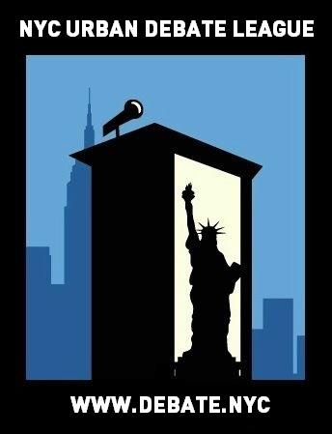
NYCUDL I Love Debate Middle School Tournament
Midwood High School

On behalf of the New York City Urban Debate League and Midwood High School, you are cordially invited to the NYCUDL I Love Debate Middle School Tournament on February 4th, 2017 for a day of exciting, fun and intense debate. We will offer two debate formats, Public Forum and Parliamentary Debate, featuring three rounds of debate for both formats.

Judges’ training will be available for individuals interested in judging Public Forum and Parliamentary Debate.

All questions, concerns and/or issues about the tournament should be directed to:

Program Manager: Courtney Kaufman – 917-774-6539 or courtney@debate.nyc

Looking forward to seeing you all,

Meagan Kowaleski – Harlem & Manhattan Programming Director, New York City Urban Debate League
Courtney Kaufman – Program Manager, New York City Urban Debate League

Registration

Registration will take place on Tabroom. We are listed as the NYC Urban Debate League circuit. If you do not have an account with Tabroom, you can easily set up through tabroom.com

Permission Slips: One permission slip per year is legally required for each student. This permission
slip protect and promote our debaters – they enable us to track attendance and record accurate debate time which is necessary for National Speech & Debate Association points and qualification for competitive tournaments. We are requesting that coaches turn in all permission slips by the Wednesday before each student’s first Saturday tournament. For this tournament, please turn in permission slips by Wednesday February 1st, 2017.

You can access the permission slip here: https://www.tfaforms.com/348080

The NYCUDL will not accept any permission slips on the day of the tournament. Without a permission slip, a student cannot debate. No exceptions.

Judges
Each school requires one judge for every two teams competing.

REGISTRATION DEADLINE FOR ALL ENTRIES IS 5PM on February 1st, 2017

Points will be on the scale of 30 points, within the range of 25-30 points. Mavericks will have their points averaged.

We will provide awards for top speakers, top teams and sweepstakes points for top schools.
We will be using NSDA rules for evidence in Public Forum. More information can be found on their website.

There will be an automatic loss for all of your teams if a judge from your school does not show up for their round.

We will be offering Tabroom drop-in help hours during rounds 1, 2, and 3 as well as during lunch on Saturday.

We will be having a coach’s meeting during round 3. Please bring enough judges to cover your teams so that we can allow all of the coaches to have round 3 off to meet.

We will be having a panel of high school debaters speaking about their debate experience to the middle school debaters. If you have questions you’d like the panelists to answer or have high school debaters who would be interested in speaking on this panel please reach out to the Program Manager, Courtney Kaufman by February 1st at 5pm. She can be reached at: courtney@debate.nyc

Topics

Public Forum:

February PF Topic: Topic: Cuba – Resolved: “The United States should lift its embargo against Cuba.”

Parliamentary Debate: February Topics:

- This House would ban alcohol advertising.
- This House believes policing is racially biased.
- This House would give Trump a chance.

IMPORTANT DATES

To submit teams into Tabroom: Wednesday, February 1st by 5PM

Check-in / Day of tournament registration: Saturday, February 4th, by 9:00AM (latest)

Once registration closes (at the beginning of the tournament) – those that are late will forfeit the first round and will debate round two – they can still observe and flow debates in round one.

WE MUST EMPHASIZE THIS RULE IN ORDER TO HAVE AN EFFICIENT, TIMELY AND WELL-MANAGED TOURNAMENT. PLEASE OBLIGE TO THIS REQUEST.

TRAVEL DIRECTIONS TO THE TOURNAMENT

Location: Midwood High School
Address: 2839 Bedford Ave, Brooklyn, NY 11210
Trains: 2 & 5, B103, B11

Buses: B103, B11, B41, B44, B44-SBS, B49, B6, B8, BM1, BM2, BM3, BM4, Q35

TOURNAMENT SCHEDULE

SATURDAY – February 4th, 2017

8:00 AM - Breakfast and Registration
9:00 AM - Registration Closes

Parliamentary Debate

10:00 AM – Round 1 Motion Announced
10:20 AM – Round 1
11:00 AM – Round 2 Motion Announced
11:20 AM – Round 2
12:00 PM – Lunch
1:00 PM – Round 3 Motion Announced
1:20 PM – Round 3
3:00 PM – Awards
4:00 PM – Dismissal

Public Forum

10:00 AM – Round 1
11:00 AM – Round 2
12:00 PM – Lunch
1:00 PM – Round 3
3:00 PM – Awards
4:00 PM – Dismissal

