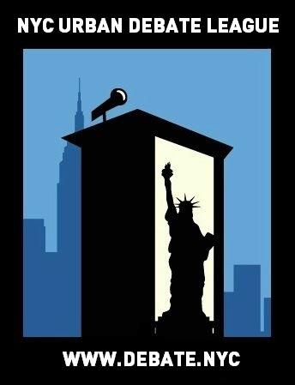
NYCUDL Harlem, Bronx, Manhattan Tournament #3
The Anderson School and The Computer School

On behalf of the New York City Urban Debate League, The Anderson School, and The Computer School you are cordially invited to the NYCUDL Harlem, Bronx, and Manhattan Middle School Tournament #3 on January 14th, 2016 for a day of exciting, fun and intense debate. We will offer two debate formats, Public Forum and Parliamentary featuring three rounds of debate for each format.

Judges’ training will be available for individuals interested in judging Public Forum and Parliamentary Debate.

All questions, concerns and/or issues about the tournament should be directed to:

Program Manager: Courtney Kaufman – 917-774-6539 or courtney@debate.nyc

Looking forward to seeing you all,

Meagan Kowaleski – Harlem & Manhattan Programming Director, New York City Urban Debate League
Courtney Kaufman – Program Manager, New York City Urban Debate League

Registration

Registration will take place on Tabroom. We are listed as the NYC Urban Debate League circuit. If you do not have an account with Tabroom, you can easily set up through tabroom.com

Permission Slips: One permission slip per year is legally required for each student. This permission
slip protect and promote our debaters – they enable us to track attendance and record accurate debate time which is necessary for National Speech & Debate Association points and qualification for competitive tournaments. We are requesting that coaches turn in all permission slips by the Wednesday before each student’s first Saturday tournament. For this tournament, please turn in permission slips by Wednesday December 11th, 2016.

You can access the permission slip here: https://www.tfaforms.com/348080

The NYCUDL will not accept any permission slips on the day of the tournament. Without a permission slip, a student cannot debate. No exceptions.

Judges
Each school requires one judge for every two teams competing.

REGISTRATION DEADLINE FOR ALL ENTRIES IS 5PM on January 11th, 2016

Points will be on the scale of 30 points, within the range of 25-30 points. Mavericks will have their points averaged.

We will provide awards for top speakers, top teams and sweepstakes points for top schools.
We will be using NSDA rules for evidence in Public Forum. More information can be found on their website.

There will be an automatic loss for all of your teams if a judge from your school does not show up for their round.

We will be offering Tabroom drop-in help hours during rounds 1, 2, and 3 as well as during lunch on Saturday.

We will be having a coach’s meeting during round 3. Please bring enough judges to cover your teams so that we can allow all of the coaches to have round 3 off to meet.

Topics

Public Forum:
Coolidge Foundation January PF Topic: Topic: Immigration – Resolved: “The U.S. federal government should increase immigration to promote greater U.S. economic growth."
Parliamentary:

- This House would abolish Native American reservations.
- This House would provide childcare to teenage parents.
- This House would overturn Brown v. EMA and ban the sale of violent video games to minors.

IMPORTANT DATES

To submit teams into Tabroom: Wednesday, January 11th by 5PM

Check-in / Day of tournament registration: Saturday, January 14th, by 9:00AM (latest)

Once registration closes (at the beginning of the tournament) – those that are late will forfeit the first round and will debate round two – they can still observe and flow debates in round one.

WE MUST EMPHASIZE THIS RULE IN ORDER TO HAVE AN EFFICIENT, TIMELY AND WELL-MANAGED TOURNAMENT. PLEASE OBLIGE TO THIS REQUEST.

TRAVEL DIRECTIONS TO THE TOURNAMENT

Location: Anderson / Computer School
Address: 100 W 77th St, New York, NY 10024
Trains: 1, B, C

TOURNAMENT SCHEDULE

SATURDAY – January 14th, 2016
8:00 AM - Breakfast and Registration
9:00 AM - Registration Closes

Parliamentary Debate
10:00 AM – Round 1 Motion Announced
10:20 AM – Round 1
11:00 AM – Round 2 Motion Announced
11:20 AM – Round 2
12:00 PM – Lunch
1:00 PM – Round 3 Motion Announced
1:20 PM – Round 3
3:00 PM – Awards
4:00 PM – Dismissal

Public Forum
10:00 AM – Round 1
11:00 AM – Round 2
12:00 PM – Lunch
1:00 PM – Round 3
3:00 PM – Awards
4:00 PM – Dismissal

