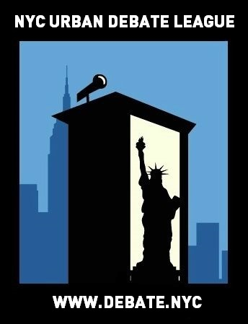
NYCUDL Middle School Invitational
PS / IS 266

On behalf of the New York City Urban Debate League and PS/ IS 266, you are cordially invited to the NYCUDL Middle School Invitational on November 5, 2016 for a day of exciting, fun and intense debate. We will offer two debate formats, Public Forum and Parliamentary, featuring three rounds of for both formats.

Judges’ training will be available for individuals interested in judging Public Forum and Parliamentary.

All questions, concerns and/or issues about the tournament should be directed to:

Program Director: Meagan Kowaleski – 1 347 440 5658 or meagan@debate.nyc.

Looking forward to seeing you all,

Meagan Kowaleski – Program Director, New York City Urban Debate League
Erik Fogel – Executive Director, New York City Urban Debate League

Registration

Registration will take place on Tabroom. We are listed as the NYC Urban Debate League circuit. If you do not have an account with Tabroom, you can easily set up one up through tabroom.com

Permission Slips: One permission slip per year is legally required for each student. This permission
slip protect and promote our debaters – they enable us to track attendance and record accurate debate time which is necessary for National Speech & Debate Association points and qualification for competitive tournaments. We are requesting that coaches turn in all permission slips by the Wednesday before each student’s first Saturday tournament. For this tournament, please turn in permission slips by Wednesday November 2, 2016.

You can access the permission slip here: https://www.tfaforms.com/348080

The NYCUDL will not accept any permission slips on the day of the tournament. Without a permission slip, a student cannot debate.

Each school may enter up to 5 teams. If there is additional room, we will be happy to accommodate request for additional teams.

Each school requires one judge for every two teams competing.

REGISTRATION DEADLINE FOR ALL ENTRIES IS 5PM on November 2nd, 2016

Points will be on the scale of 30 points, within the range of 25-30 points.

We will provide awards for top speakers, top teams and sweepstakes points for top schools.

Topics

Public Forum:
National November PF Topic: Topic: Fourth Industrial Revolution (Industry 4.0) – Resolved: On balance, the benefits of the Internet of Things outweigh the harms of decreased personal privacy.

Parliamentary:
- This house would give undocumented immigrants a path to citizenship.
- This house believes a government should have the right to spy on its own citizens.
- This house would pay reparations to African Americans.

IMPORTANT DATES

To submit teams into Tabroom: Wednesday, November 2nd by 5PM

Check-in / Day of tournament registration: Saturday, November 5th, by 9:30AM (latest)

Once registration closes (at the beginning of the tournament) – those that are late will forfeit the first round and will debate round two – they can still observe and flow debates in round one

WE MUST EMPHASIZE THIS RULE IN ORDER TO HAVE AN EFFICIENT, TIMELY AND WELL-MANAGED TOURNAMENT. PLEASE OBLIGE TO THIS REQUEST.

TRAVEL DIRECTIONS TO THE TOURNAMENT
Location: PS / IS 266
Address: 74-10 Commonwealth Boulevard, Queens, NY 11426
Bus

Q36, Q43, Q46, QM6

TOURNAMENT SCHEDULE

SATURDAY – NOVEMBER 5th, 2016

8:00 AM - Breakfast and Registration
9:30 AM - Registration ends
10:10 AM - Parli Prep Begins
10:30 AM - Round 1
11:10 AM - Parli Prep Begins
11:30 AM - Round 2
12:00 PM - Lunch
12:30 PM – Parli Prep Begins
12:50 PM - Round 3
2:00 PM – Awards
3:30 PM – Dismissal

