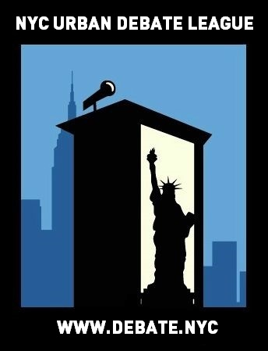
NYCUDL Brooklyn / Queens Middle School Tournament #1
Hunters Point Community Middle School

On behalf of the New York City Urban Debate League and Hunters Point Community Middle School, you are cordially invited to the NYCUDL Brooklyn/Queens Middle School Tournament #1 on October 22, 2016 for a day of exciting, fun and intense debate. We will offer two debate formats, Public Forum and Parliamentary, featuring three rounds of for both formats.

Judges’ training will be available for individuals interested in judging Public Forum and Parliamentary.

All questions, concerns and/or issues about the tournament should be directed to:

Program Director: Aubrey Semple – 347-440-5809 or aubrey@debate.nyc

Looking forward to seeing you all,

Aubrey Semple – Program Director, New York City Urban Debate League
Erik Fogel – Executive Director, New York City Urban Debate League

Registration

Registration will take place on Tabroom. We are listed as the NYC Urban Debate League circuit. If you do not have an account with Tabroom, you can easily set up through tabroom.com

Permission Slips: One permission slip per year is legally required for each student. This permission
slip protect and promote our debaters – they enable us to track attendance and record accurate debate time which is necessary for National Speech & Debate Association points and qualification for competitive tournaments. We are requesting that coaches turn in all permission slips by the Wednesday before each student’s first Saturday tournament. For this tournament, please turn in permission slips by Wednesday October 19, 2016.

You can access the permission slip here: https://www.tfaforms.com/348080

The NYCUDL will not accept any permission slips on the day of the tournament. Without a permission slip, a student cannot debate.

Each school may enter up to 5 teams. If there is additional room, we will be happy to accommodate request for additional teams.

Each school requires one judge for every four teams competing.

REGISTRATION DEADLINE FOR ALL ENTRIES IS 5PM on October 19TH, 2016

Points will be on the scale of 30 points, within the range of 25-30 points.

We will provide awards for top speakers, top teams and sweepstakes points for top schools.

Topics

Public Forum:
National September/October PF Topic: Topic: US Constitution – Resolved: In United States public K-12 schools, the probable cause standard ought to apply to searches of students.

Parliamentary:
- This house would abolish the Electoral College.
- This house would adopt a mandatory dress code in NYC schools.
- This house condemns big pharma.

IMPORTANT DATES

To submit teams into Tabroom: Wednesday, October 19th by 5PM

Check-in / Day of tournament registration: Saturday, October 22nd, by 9:00AM (latest)

Once registration closes (at the beginning of the tournament) – those that are late will forfeit the first round and will debate round two – they can still observe and flow debates in round one

WE MUST EMPHASIZE THIS RULE IN ORDER TO HAVE AN EFFICIENT, TIMELY AND WELL-MANAGED TOURNAMENT. PLEASE OBLIGE TO THIS REQUEST.

TRAVEL DIRECTIONS TO THE TOURNAMENT

Location: Hunter Point Community Middle School
Address: 1-50 51st Avenue, 3rd Floor, Long Island City, 11101
Subway
7 Train – Vernon Blvd – Jackson Avenue
G Train – 21st Street

Bus
B43, B52, Q103
The school is about 4 blocks from the Vernon Blvd/Jackson Avenue 7 train station.
15 minute walk from the G train at 21st Street / Van Alst and Court Square train station.

Street parking is available or you can park at the East River Ferry parking lot located at 5400 2nd Street at 54th Avenue. All day parking is $5.00. The lot is open from 6am to 9pm.

TOURNAMENT SCHEDULE

SATURDAY –OCTOBER 22nd, 2016

8:00 AM - Breakfast and Registration
9:00 AM - Registration ends
10:00 AM - Round 1
11:00 AM - Round 2
12:00 PM - Lunch
12:45 PM - Round 3
2:00 PM – Awards
3:00 PM – Dismissal

