September 1st, 2016

Dear Forensics Coach,

On behalf of the Princeton Debate Panel, it is our pleasure to invite you and your forensics team to the 2016 Princeton Classic, to be held at Princeton University from **Friday, December 2nd, 2016** to **Sunday, December 4th, 2016**.

The tournament will consist of competition in Varsity and Novice Lincoln-Douglas Debate, Open Public Forum Debate, Congressional Debate, and six Speech events. We offer five prelim rounds in Individual Events, six prelim rounds in LD and Public Forum, and three sessions in Congress. *Semi-finalists*in Varsity LD, *quarterfinalists* in PF, *elimination round participants*in IE and Extemp, and for the first year, *finalists* in Congress will earn a bid to their respective Tournament of Champions.

Joining us this year as Tab Director is Jim Menick, who will also run LD tab with Sheryl Kaczmarek of Lexington (MA). Additionally, Dario Camara of Columbus (FL) and Carol Cecil of Braddock (FL) will direct Public Forum tab; Brother John McGrory of Chaminade (NY) and Martin Page of Ridge (NJ) will oversee Congress tab; and Joe Vaughan of Scarsdale (NY), Lydia Esslinger of Syosset (NY), and Barb Guiliano of St. Joseph’s (PA) will run Speech tab.

Our tournament last year drew more than a thousand participants from more than one hundred schools, and we hope our tournament will continue to grow in this, our twentieth year.

This invitation should answer any questions you may have about the tournament; please take the time to read it in its entirety, since some things have changed from previous years. If you need any additional information, **please email us at princetonclassic2016@gmail.com**.

We hope your school year and forensics season are off to a great start, and look forward to seeing you all in Princeton this December!

Best wishes,

Sid Anand, Pragya Malik, Peter Koczanski

*Tournament Directors*

|  |  |
| --- | --- |
| https://upload.wikimedia.org/wikipedia/en/0/06/Logo_of_the_National_Speech_and_Debate_Association.jpghttp://www.princetonsocal.org/wp-content/uploads/2011/09/Shield.gif**2016 PRINCETON CLASSIC**  High School Forensics Tournament  Princeton University  Friday, December 2nd – Sunday, December 4th | |
| **For any problems during the tournament, please contact:** | |
| Sid Anand (TAB): (703) 819-4863  Pragya Malik (ADMIN): (518) 231-1295 | Jim Menick (TAB): (914) 471-6351  Peter Koczanski: (631) 408-5412 |
| princetonclassic.tabroom.com | [princetonclassic2016@gmail.com](mailto:princetonclassic2016@gmail.com) |

***Event Rules***

**Varsity and Novice Lincoln-Douglas Debate**

The resolution will be the November-December NSDA topic. Both divisions will follow the 6-3-7-3-4-6-3 format, with **4 minutes** of prep time. Ties will be broken based on record, adjusted points, total points, double-adjusted points, judge variance, opponent wins, and flip of a coin, in that order. We usually break all 4-2 debaters, but no guarantees. Novice is limited to first-year forensics competitors only and will use the November-December topic; the Northeast Modest Novice topic does not extend into December. The TOC bid is at VLD semi-finals.

**Public Forum Debate**

There will be a single, open division of PF. We will follow all NSDA rules for the event as they stand for the start of the school year and use the NSDA topic for December 2016. Debaters will have **2** **minutes** of prep time. Ties will be broken using the same criteria as Lincoln-Douglas Debate. The event will break to an appropriate level. As with last year, Public Forum will feature limited open tab of the kind used at other tournaments around the country. The TOC bid is at *quarterfinals*. Rounds will take place at **Princeton HS** on Friday and at **Princeton University** campus on Saturday.

**Congressional Debate**

This year, there is a TOC bid at *finals*. There will be a single, open division of Congressional Debate. Chambers will be composed of no more than 25 members, although 20 is the target. Sunday’s competition will again feature a semifinal round in the morning and a final round in the afternoon. Chamber assignments will be posted on Monday, November 21. Semi-supersession legislation, as well as supersession topic areas, will be posted on Wednesday, November 23. Supersession legislation will be posted on Friday, November 25.

All legislation is due to [jmcgrory@chaminade-hs.org](mailto:jmcgrory@chaminade-hs.org) by Sat. Nov 19. Each student may submit one bill for prelims. Bills must have not only the name of the school, but also the name of the student submitting it. Bills must be no longer than 1 page of 8 ½ by 11. Bills are to be double spaced, with each line of the bill numbered.

**Speech Events**

This year, we once again an NIETOC bid school. Extemp, Oratory, DI, HI and Duo will follow NSDA rules. We will use the NCFL’s guidelines for published material in interp events. The grace period will be 30 seconds for all speech events. Any IE participant who exceeds the grace period may not receive a rank of 1 in the round; any further penalty will be at the discretion of the judge. A participant may only be penalized for a time violation if the judge has used a precise timing device and notes the penalty on the ballot. There will be 5 preliminary rounds unless noted at the tournament. Rounds will take place at John Witherspoon Middle School on Saturday.

Speech events will break to quarterfinals, “super-semifinals”, or semifinals. Tabbing is cumulative, with the worst preliminary rank dropped after the initial elimination break. The Extemp final round will feature cross-examination in accordance with NSDA rules. The Extemp TOC bid is at the first break.

***Judging Policies***

**Judging Requirements**

Teams should bring the following number of qualified judges:

**LD: 1 judge/ 3 entries**

**PF: 1 judge/ 3 teams**

**Speech: 1 judge/ 5 entries**

**Congress: 1 judge/ entire entry**

Please keep in mind that a qualified judge understands the activity, speaks English, and is either experienced sitting in the back of the room flowing the round or has been carefully trained by the team he or she is accompanying. A qualified judge knows how to assign ranks or wins/losses, speaker points, and knows how to fill out a ballot.

Judges in all divisions except speech are **obligated to stay and judge one round past any round in which their students are competing**. If there are run-off rounds in debate, all judges are obligated for that round, and for the following round (i.e., if there is a run-off, all judges are obligated for the doubles round). **Judges in speech are required to stay for all rounds.**

Note that the Varsity LD and Novice LD pools are completely separate and **must be covered separately**; e.g., if you have one VLDer and one NLDer, you need one judge for VLD and another judge for NLD. Congress judges might be swapped into another judging pool; please indicate at registration which other pool a Congress judge would like to judge if we cannot use him/her in Congress. Likewise, qualified Speech judges may be asked to judge a round of Congress.

**MJP**

Any Varsity LD school with proper judge coverage will be able to select rankings for the pool using Mutual Judge Preferencing (MJP) on tabroom.com. We will note on the list the rankings (prefers circuit, prefers traditional, trained newcomer) given by the submitting schools. MJP will begin the Tuesday morning prior to the tournament, and end Thursday evening. Any schools that drop judges after MJP starts will lose their own rankings.

We reserve the right to assign Varsity judges to the Novice pool. This will improve the quality of the novice judging and is often the best use of judging resources, as we have seen at other tournaments.

**Paradigms**

We expect Varsity LD judges to publish paradigms at <http://judgephilosophies.wikispaces.com/>. Novice judges should be willing to indicate to competitors before a round a general sense of their vision of LD (if any) or a sense of their experience, to aid competitors in choosing how best to make their arguments.

***Tab & Ballots***

**Open Tab & Results**

We will publicly post the results of every round in LD and PF after each round is tabbed, to serve as a confirmation. Though judges in debate events are not required to disclose their decisions, they are highly encouraged to do so and give feedback and critiques. Pairings will be posted online. This year, we will be using **e-balloting** in LD for the first time. All other judges will be **required** to attend judge call to pick up ballots. We will post more information at the start of the tournament.

**Ballots and Awards:**

Awards will be given to all competitors reaching elimination rounds (not including runoff rounds). Please pick them up during the awards ceremony, or arrange to have someone else do so on your behalf. **We do not mail trophies**.

Teams with no entries in elimination rounds are allowed to pick up ballots early, though ballots may not be ready until after the first round Sunday morning. If you anticipate leaving early, bring an envelope of sufficient size and postage, label it with your school name, and deliver it to tab so we can send it after the tournament. We will not release ballots early to teams with entries competing in elimination rounds.

***Registration and Caps***

General Registration will take place at Whig Hall. Registration for schools with **Lincoln Douglas or Public Forum** entries must take place on **Friday**.

Schools with **only Speech** **and** **Congress** **entries** may register in Whig or by calling to confirm their registration on Friday. Those who call in will pay their registration fees **Saturday morning i**n Tab.

A more detailed registration schedule can be found later in the invitation.

**Caps and Limits**

Immediately after registration, we will place all entries on the waitlist. Shortly after, we will begin clearing as many people off the waitlist as the tournament allows.

**Eligibility and Adult Supervision**

Only teams officially representing their own bona fide degree-issuing high schools are eligible to register. *The tournament does not accept independent entries, camp entries, hybrid entries, etc.* Additionally, no teams will be accepted into the tournament without a responsible adult chaperone on site for the duration of the tournament, unless other plans are made in advance with the Tournament Director. An adult, for these purposes, is defined as a college graduate twenty-one years of age or older, presumably a school employee, a parent, or someone else who has been explicitly empowered to care for that student in the event of a medical or other emergency. The contact information for this adult must be given to the Tab Room at registration.

**Double Entry**

A participant may enter up to two different speech events. Debate (including Congress) entries may not double enter.

***Fees and Fines***

*Fees are frozen on Monday 11/21 at 9:00 PM*

**Entry Fees**

VLD $80/entry

NLD $60/entry

PFD $90/entry

Duo $40/entry

Other IE $35/entry

Congress $50/entry

**Hired Judge Fees**

LD Hired Judging $75/ uncovered entry

PFD Hired Judging $75/ uncovered entry

IE Hired Judging $50/ uncovered entry

CON Hired Judging $50/ uncovered entry

(max charge 5 entries)

**Fines and Deadlines**

Late drops/adds after Thu. 11/24 at 9:00 PM:

$10/change

Unreported drops after Thu. 11/24 at 9:00 PM:

$50/drop

Judge misses a preliminary round:

$25/round

Judge misses an elimination round:

$50/round

Judges may compensate for fines by judging rounds beyond their assignment. However, schools with unpaid fines will not be given ballots or awards, and will be prevented from registering at other tournaments until those fines are paid.

***All payment is due at registration.***

***Make checks out to* “Princeton Debate Panel”**

***Safety Policy***

The **non-emergency** phone number for Princeton University Public Safety is (609) 258-1000. Please make your students aware of this number for **non-tournament-related** security concerns, as well as the Tournament Director phone numbers on the second page for **tournament-related** concerns.

In the case of an **emergency**, dial 911 or Princeton Public Safety’s emergency number, (609) 258-3333.

We want our tournament to be a safe environment. Any and all complaints regarding tournament safety will be taken seriously. Please come to tab as soon as possible with any concerns – there will be male and female Debate Panel members present to answer any questions you might have and relay concerns to the tournament directors. We will also try to post numbers for these members at the beginning of the tournament.

That being said, the Princeton Classic and the PDP can take no responsibility for the health and safety of students beyond notifying any accompanying adults of concerns or problems as we become aware of them. If a student falls ill or withdraws from competition during the tournament, please notify tab immediately.

***Tournament Hotel***

The official tournament hotel for this year will be the DoubleTree Hotel in Princeton. Participants in the tournament can book rooms at this hotel at a discounted rate of $115/night for a room with two queen-sized beds. There will be shuttles in the morning and at night from the hotel to the campus during the weekend of the tournament. You may make reservations at the hotel by phone at 1-800-222-TREE or 609 945-2509 and mention the Princeton Debate Panel to get the discounted rate.

***Schedule***

For the most current tournament schedule, please check the tournament website (see footer). All posted schedules are subject to change before or during the tournament.

*All rules are subject to change. The tournament will make you aware of any changes at registration.*

**Registration Schedule**

**Friday** in Whig Hall

**2:30-4:00**

Schools with LD/PF debaters *must* register. Schools without debaters *may* register.

**7:00-8:00**

Schools without debaters may register in Whig or by calling to confirm their registration. Those who call in will pay their registration fees Saturday morning in Tab. Schools arriving later than 5pm *must call* registration before 5pm, even if they have no registration changes.

**LD & PF schedule**

**Friday** LD on PU campus, PF at Princeton HS

**4:00**  Princeton HS Opens

**4:30**  Coordinated Walk to Princeton HS for PF

**5:00**  VLD, NLD, PFRound 1

**7:30**  VLD, NLD, PFRound 2

**Saturday** LD and PF on PU campus

**8:00** VLD, PF Round 3

**10:00** NLD Round 3

**10:30** PF Round 4

**12:00** VLD Round 4

**2:00** NLD Round 4, PF Round 5

**4:00** VLD Round 5

**4:30** PF Round 6

**6:00** NLD Round 5

**7:30** PF Round 7

**8:00** VLD Round 6

**Sunday** on PU campus

**8:00** PF Runoffs, VLD Runoffs, NLD Round 6,

**10:30** PF Doubles, VLD, NLD,

**8:30-2:30** Elimination rounds in all events

**3:00**  Awards

**Speech Schedule**

Extemp draw starts 30 minutes before round.

Judges must pick up ballots 15 MINUTES PRIOR TO THE ROUND.

**Saturday** at John Witherspoon Middle School

**8:00** John Witherspoon Middle School opens

**8:30** Mandatory Judge’s Meeting

**9:00**  DI, Duo, HI, OI, OO

**10:30** DI, EXT, HI, OI

**12:00** Duo, EXT, OI, OO

**2:00** DI, Duo, EXT, HI, OO

**3:30**  EXT, HI, OI, OO

**5:00**  DI, Duo, EXT, OI

**6:30** DI, Duo, HI, OO

On PU Campus

**General Assembly** in McCosh 50

**Judges Lounge** in McCosh 26

**Tab** in McCosh 47

**REG** in Whig Hall, 1st floor

**7:00** EXT, OI, Quarters

**Sunday** on PU campus

**10:30**  DI, Duo, EXT, HI, OI, OO, Semis

**1:00** DI, Duo, EXT, HI, OI, OO, Finals

**3:00**  Awards

**Congress Schedule**

**Saturday** on PU campus

**9:00** Session 1

**1:00** Session 2

**4:30** Session 3

**Sunday** on PU campus

**8:30** Semi-supersession

**12:00** Supersession

**3:00**  Awards

**NOTE: There will NOT be a shuttle to the off-campus tournament sites.**

**Walking and driving directions can be found at the back of the invitation.**

**Campus Building Map**

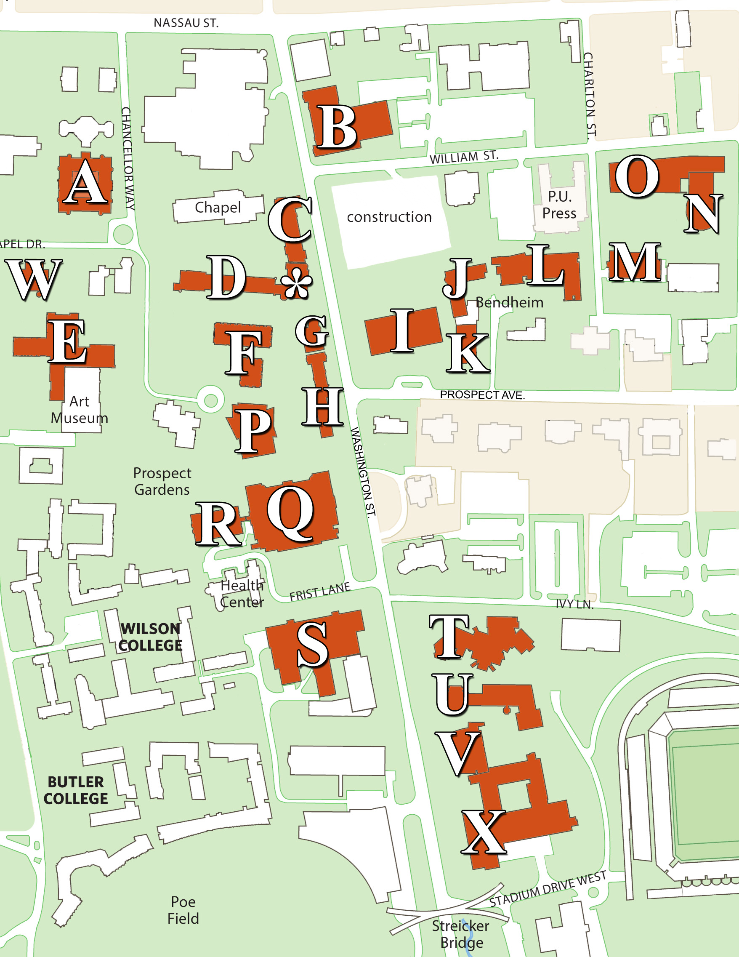

|  |  |
| --- | --- |
| **McCosh 50** | **\*** |
| **Whig (Reg)** | **W** |
| 1879 Hall | H |
| Architecture | F |
| COS | N |
| Corwin | J |
| Dickinson | C |
| East Pyne | A |
| Fine | U |
| Fisher | K |
| Friend | O |
| Frist | Q |
| Green | B |
| Guyot | S |
| Jadwin | X |
| Jones | R |
| Lewis Lib. | T |
| Marx | G |
| McCormick | E |
| McCosh | D |
| McDonnell | V |
| Robertson | I |
| Sherrerd | M |
| Wallace | L |
| Woolworth | P |

**On-Campus Parking Map**

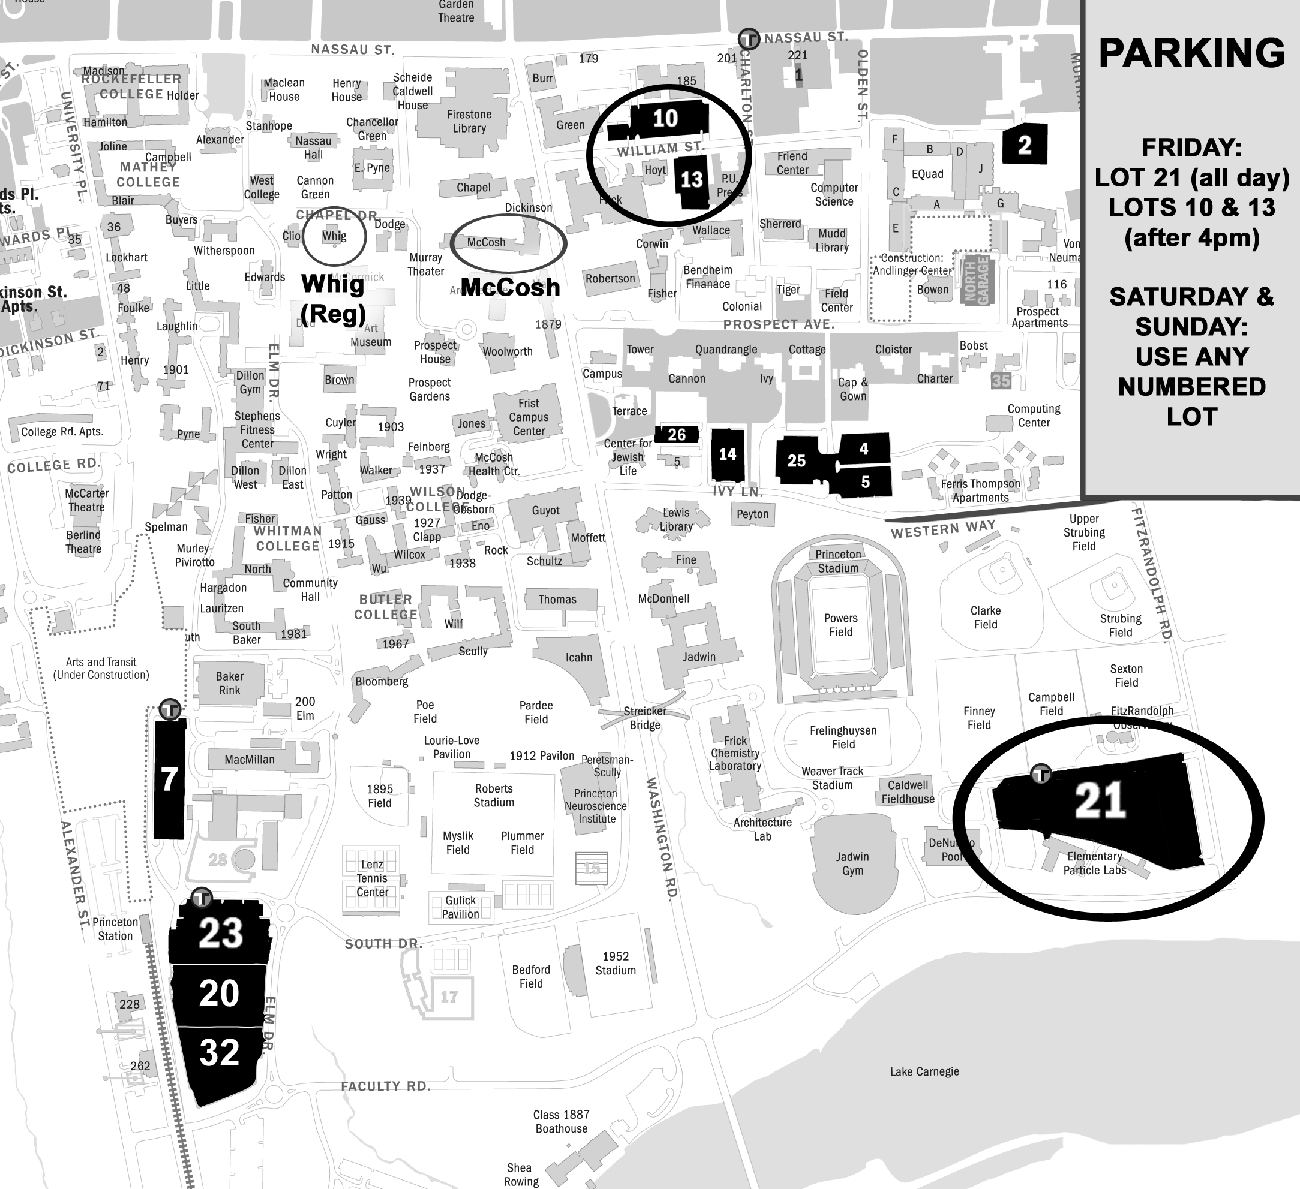

**Walking/Driving Directions to Princeton High School**

**151 Moore St, Princeton, NJ 08540**

**Distance: 0.8 miles**

**Time: 15 minutes walking, 5 minutes driving**

1. Once on Princeton campus, make your way towards Nassau Street. Our map gives Whig Hall as the reference point to help you get to Nassau Street.
2. Once on Nassau Street, turn right and walk down the street for roughly a quarter mile until you reach Moore Street.
3. Turn left on to Moore Street. Continue walking for about a half mile. Princeton High School will be on your right.



**Walking/Driving Directions to John Witherspoon Middle School**

**217 Walnut Lane, Princeton, NJ 08540**

**Distance: 1.2 miles**

**Time: 20 minutes walking, 5 minutes driving**

1. Once on Princeton campus, make your way towards Nassau Street. Our map gives Whig Hall as the reference point to help you get to Nassau Street.
2. Once on Nassau Street, turn right and walk down the street for roughly a half mile until you reach Chestnut Street.
3. Turn left on to Chestnut Street. After 0.2 miles, Chestnut Street will become Walnut Street. Continue on Walnut Street for 0.4 miles. John Witherspoon Middle School will be on your right.
4. Parking for cars and vans is available at the middle school where indicated below.
5. DRIVING NOTE: The Front Gate will be closed on Saturday. Loop around on Alexander Street or exit on Co Road 526/Washington Street depending on where you parked.

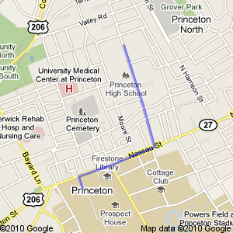

**WHIG**

**JWMS**

**Parking**

**FRONT GATE**

**Washington St**

**Alexander St**

X