HS TOURNAMENT 5 INFO PAGE

Where: Charlestown HS When: February 26th – 27th
Who: All Divisions – All High Schools & Guests Rhode Island UDL

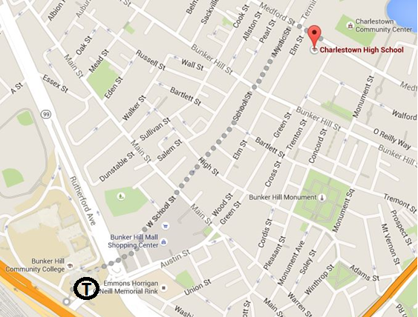

Transportation
Location:
Charlestown High School (240 Medford St, Charlestown, MA 02129)

Parking:
Parking available along most streets nearby. Parking space are available along Medford Street and also generally available on Elm St and Polk St.

Directions:
By T: Take the Orange Line to the Community College T Stop, take a left out of the station and walk northeast down Austin Street towards the Bunker Hill Mall Shopping Center. Then continue down Green Street and finally onto Polk Street to arrive at the school. The West School Street exit is also mapped above, though less direct.

Emergency Contact Information: Anna Rodriguez, Tournament Director, cell: 857-334-4142
Schedule

Registration Information for Coaches
Friday |  | Saturday
2:30pm – 3:30pm | Team Arrival and Registration | 7:30am – 8:30am | Registration and Breakfast
3:30pm – 4:15pm | Dinner | 8:30am – 10:15am | Round 3
4:15pm – 6:15pm | Round 1 | 10:15am – 12:00pm | Round 4 (Coach Meeting)
6:15pm – 8:00pm | Round 2 | 12:00pm – 1:00pm | Lunch
 |  | 1:00pm – 1:45pm | Awards Assembly
 |  | 2:00pm – 4:00pm | Elimination Round 1
 |  | 4:00pm – 6:00pm | Elimination Round 2
 |  | 6:00pm – 6:30pm | Dinner
 |  | 6:30pm – 8:30pm | Elimination Round 3
8:00pm – 9:30pm | Bus running continuously from Charlestown HS to Community College T Stop | 4:00pm – 9:00pm | Bus running continuously from Charlestown HS to Community College T Stop
Pre-registration Deadline: February 12th, 2016 (Please complete this on time, it is important to guarantee that you have a bus and enough food for your students, and enough judges!)
Early Registration: Wednesday February 24th – 5:00pm (Bonus Personalized Tournament Reminders!)
Registration Deadline: Thursday February 25th – 5:00pm
Tournament Day: Please keep your registration up-to-date on Tabroom, this will make you check-in when you arrive at the tournament quick and easy!

Evidence Information
Please remember that our Novices our now debating the Drone Surveillance case. Novices will not be allowed to compete using the Immigration Surveillance evidence.

The Spanish Division debaters are allowed to debate using the original core files, but are highly encourage to use the updated translations which were distributed by Anna to all schools.

Chaperoning and Judging for Coaches
Chaperoning: Coaches, please be reminded that at least one coach from your school needs to present in the building at all times while any of your students are still in the building (competing or otherwise).

Judging: In order to ensure that we start on time and fill rounds with qualified judges, coaches should expect to judge during the tournament. Our greatest needs are usually during Round 1 and Round 3. Please check every pairing every round to see if you are needed!

