HS Tournament 3 – English HS – December 11th-12th

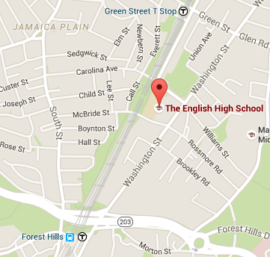
Location:
The English High School
144 McBride Street
Jamaica Plain, MA 02130

Parking:
Parking available in school lot and lot across from main entrance by athletic fields.

Directions:
By T: Take the Orange Line to Green Street T Stop, take a right out of the station and a right turn to walk down Amory St to the main entrance.

By Bus: The following buses go to Forest Hills T Station: 16, 21, 30, 31, 32, 34, 34E, 35, 36, 37, 38, 39, 40, 42, 50, and 51. From Forest Hills Station walk north along Washington Street or up the Southwest Corridor to English HS.

Emergency Contact Information: Anna Rodriguez, Tournament Director, 857-333-5283

Schedule:
Friday |  | Saturday
2:30pm – 3:30pm | Team Arrival and Registration | 7:30am – 8:00am | Registration and Breakfast
3:30pm – 4:15pm | Dinner | 8:15am – 10:00am | Round 3
4:15pm – 6:15pm | Round 1 | 10:00am – 12:00pm | Round 4
6:15pm – 8:00pm | Round 2 | 12:00pm – 1:00pm | Lunch
 |  | 1:00pm – 1:45pm | Awards Assembly
 |  | 2:00pm – 4:00pm | Elimination Round 1
 |  | 4:00pm – 6:00pm | Elimination Round 2
 |  | 6:00pm – 6:30pm | Dinner
 |  | 6:30pm – 8:30pm | Elimination Round 3
8:00pm – 9:30pm | Bus running continuously from English HS to  Forest Hills Station | 4:00pm – 9:00pm | Bus running continuously from English HS to  Forest Hills Station

