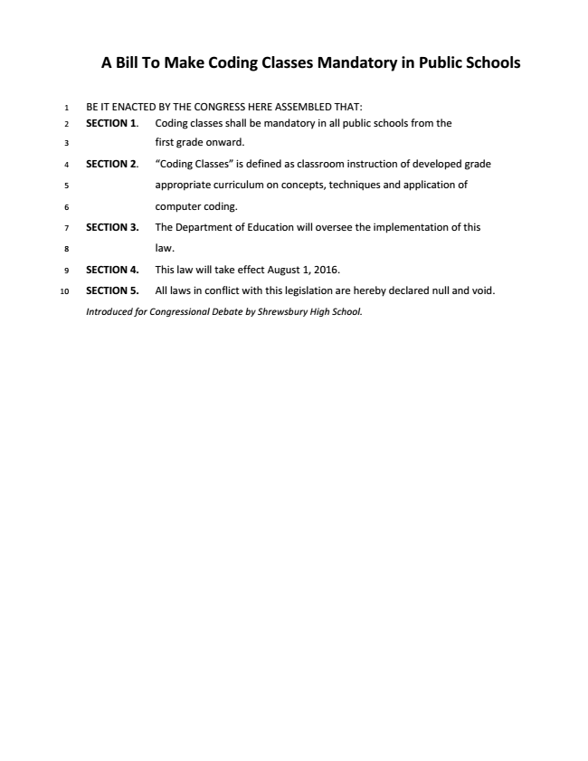
The Transportation and Economic Growth Act of 2015

BE IT ENACTED BY THE CONGRESS HERE ASSEMBLED THAT:
Section 1. The Federal Gasoline Tax will be raised to forty five cents per gallon with the funds going to improvements in public transportation.
Section 2.
- Federal Gasoline tax shall be defined as a tax on every gallon of gasoline sold.
- Public Transportation shall be defined as buses, trains, subways, and other forms of transportation that charge set fares, run on fixed routes, and are available to the public.

Section 3. The Internal Revenue Service will hereby oversee the enforcement and collection of the Federal Gas Tax and transferring funds to the Department of Transportation.
- The Department of Transportation will be responsible for overseeing and distributing funds to states as necessary to improve their Public Transportation systems.
- States will be required to submit an annual report, to the Department of Transportation, on progress coming from these funds to ensure proper use of them.
SECTION 4. This legislation will take effect the first day of the first fiscal year after passage.
Section 5. All laws in conflict with this legislation are hereby declared null and void.
Introduced for Congressional Debate,
Rep. Joseph McCauley
Catholic Memorial School

A Bill to Enact the Smarter Sentencing Act

BE IT ENACTED BY THE STUDENT CONGRESS HERE ASSEMBLED THAT:
Section 1. The full text of the Smarter Sentencing Act of 2015 (S. 502) is hereby enacted.
Section 2. The Smarter Sentencing Act reforms prison sentencing by reducing mandatory minimum sentences for non-violent drug offenses, applying the Fair Sentencing Act of 2010 retroactively, and attempting to reduce prison overcrowding and racial disparities.
Section 3. The United States Department of Justice shall be responsible for the implementation of this legislation.
SECTION 4. This legislation shall take effect 60 days after passage.
Section 5. All laws in conflict with this legislation are hereby declared null and void.
Respectfully submitted,

Natick High School

A Bill to Make Voting Easier

BE IT ENACTED BY THE STUDENT CONGRESS HERE ASSEMBLED THAT:
Section 1. All states will put in measures to increase voter participation using methods to increase ease of both registration as well as voting.
Section 2. Such methods would include:
- All states will support online voter registration
- All states will support early voting and absentee ballots
- All states will support measures to allow voters to submit their vote via mail
Section 3. The Federal Election Commission (FEC) will take responsibility for this legislation.
- 6 more members will be added to the FEC. They will have 6 year terms, and they will be appointed by the President and confirmed by the Senate. They will serve on the Enfranchisement Committee. The group will discuss current and proposed nationwide methods to increase voter participation.
- The Department of Defense will re-open Secure Electronic Registration and Voting Experiment (SERVE) as determined by the Department. Results will be reported to the Enfranchisement Committee within 8 years of this legislation coming into effect, and the Committee will make the decisions to continue the research program, cancel it, or set procedures for voting online on a national scale.
- All states that do not comply with the mandates of the Enfranchisement Committee and this legislation will lose 25% of their allocated highway funds.
SECTION 4. This legislation shall take effect at the January 1st, 2019.
Section 5. All laws in conflict with this legislation are hereby declared null and void.

Respectfully submitted,
Rep. Aman Jha
Needham High School

A Resolution to Mediate Negotiations on Territorial Disputes in the South China Sea to Ease Regional Tensions
WHEREAS, China’s dashed line territorial claims in the South China Sea have violated international law; and
WHEREAS, These territorial claims have caused instability around the South China Sea; and
WHEREAS, This regional instability has caused countries, including our allies near the South China Sea, to be taken advantage of economically and militarily; and
WHEREAS, China has cooperated with U.S.-led negotiations in the past; and
WHEREAS, If world powers stay silent, China will continue to control the South China Sea economically and militarily and seize land that belongs to other countries, many of which are our allies; now, therefore, be it
RESOLVED, The U.S. will attempt to mediate negotiations to settle territorial disputes in the South China Sea between China and other nations; and, be it
FURTHER RESOLVED, If the territorial disputes are resolved via these negotiations, the U.S. shall eliminate it’s military presence in the South China Sea, contingent upon China’s adherence to the agreements made; and, be it
FURTHER RESOLVED, If China does not reasonably engage in negotiations, the U.S. will consider filing charges in the United Nations International Court of Justice to attempt to end these territorial disputes.
Introduced by Thomas Garrison, Newton South HS

Superscenario

(Kabul)- Breaking news from Afghanistan reports that October 21st, 2015’s series of drone strikes which reportedly killed over eighty people, including over three dozen members of the US chapter of Borderless Obstetricians and Pediatricians, sources say. The US chapter chose to remain in the country following the withdrawal of the international organization after the bombing of a major hospital earlier this month. Military spokesperson Henrietta Flashman noted that “while unacceptable, we would like to note that our drone system has greatly increased its effectiveness from the Operation Haymaker Days, We are in a war zone, given the many brownouts in this part of the country we know not anyone’s school days.”Dr. William Brydon, the only survivor of the attack, remains unavailable for comment . The United States government as promised a full investigation.
.

